**Evaluate web pages within a three-hop distance from the home page on Archive. Today and Trova**

AI inspector Exported Files :

<https://drive.google.com/drive/folders/1zue1SQ3m_hs3GcgpKAdZpLjlx4L0yfSH?usp=sharing>

IBM Exported Files : <https://drive.google.com/drive/folders/19ivJCTUxNicY7eCD_iwvSsyK74jZ4UUr?usp=sharing>

**Links** :

Archive.today list of web pages :

1 ) <https://archive.ph/>

2) <https://archive.ph/20200421201055/https://rt.live/>

3)<https://archive.ph/20140626212928/https://www.google.com/maps/@-12.1858563,96.8293918,366m/data=!3m1!1e3>

4) <https://archive.is/www.usatoday.com>

5) <https://archive.is/NWtsj>

6) <https://archive.is/www.youtube.com>

7) <https://archive.is/btSNz>

8) <https://archive.is/www.cnn.com>

9) <https://archive.is/amFiR>

10) <https://archive.is/www.dominos.com>

11 <https://archive.is/W2uf0>

12 [https://archive.ph/*.microsoft.com](https://archive.ph/*.microsoft.com)

13 <https://archive.ph/0.0.microsoft.com>

14 <https://archive.ph/MR6xP>

15 <https://archive.is/www.indiatoday.com>

16 <https://archive.is/wYNt6>

17<https://archive.is/www.github.com>

18 <https://archive.is/eOx7L>

19 <https://archive.is/www.yahoo.com>

20 <https://archive.is/JR0yR>

21 <https://archive.is/u7pQx>

22 <https://archive.is/www.cocacola.com>

23 <https://archive.is/1ScQd>

24 <https://archive.is/u7pQx/image>

25 <https://archive.is/www.espn.com>

26 <https://archive.is/www.samsung.com>

27 <https://archive.is/VwcBe>

28 <https://archive.is/www.mcdonalds.com>

29 <https://archive.is/0mbgL>

30 <https://archive.is/www.bmw.com>

31 <https://archive.is/8uBtH>

32 <https://archive.is/www.cartoonnetwork.com>

33 <https://archive.is/jZUqI>

34 <https://archive.is/www.audi.com>

35 <https://archive.is/Pj6gm>

Website link: <https://archive.ph/>

Wave tool :

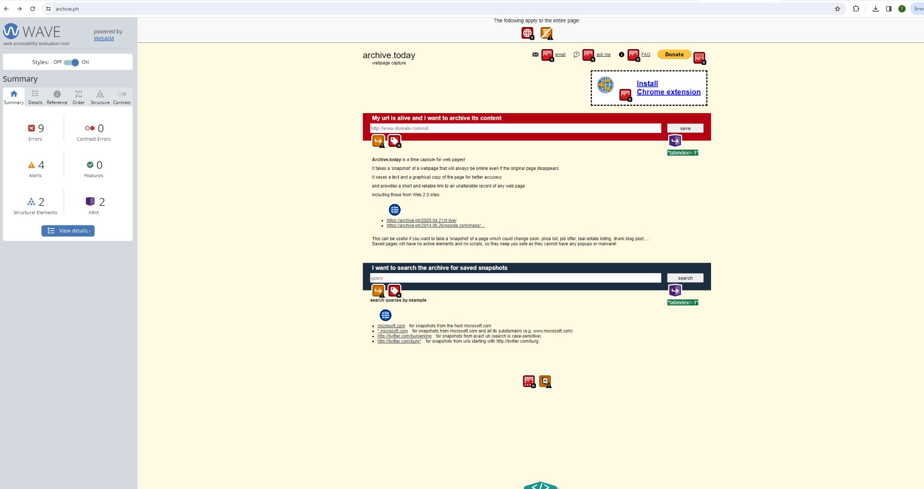

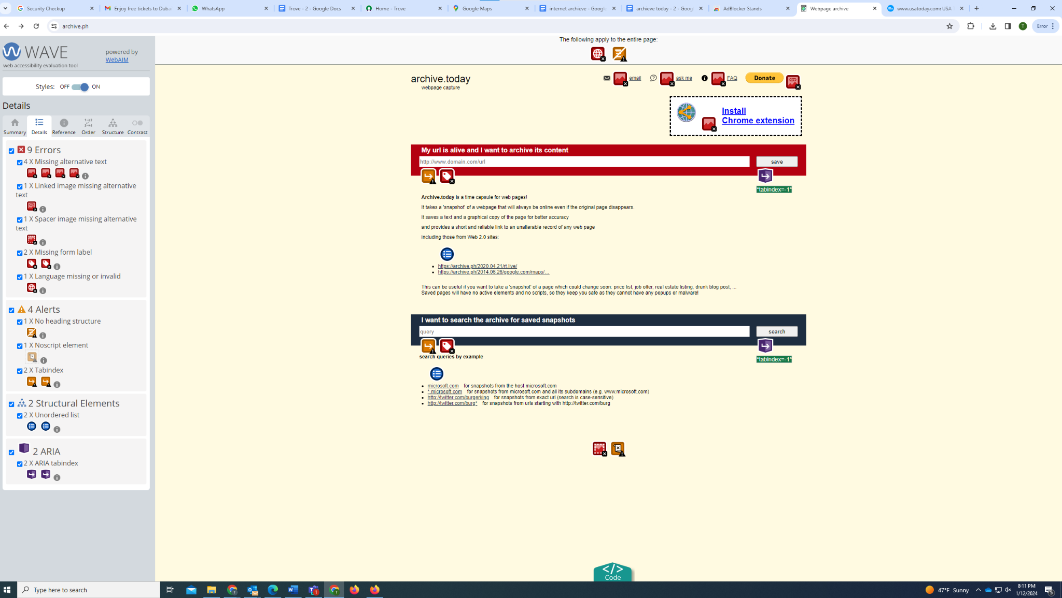

Accessibility :

IBM :

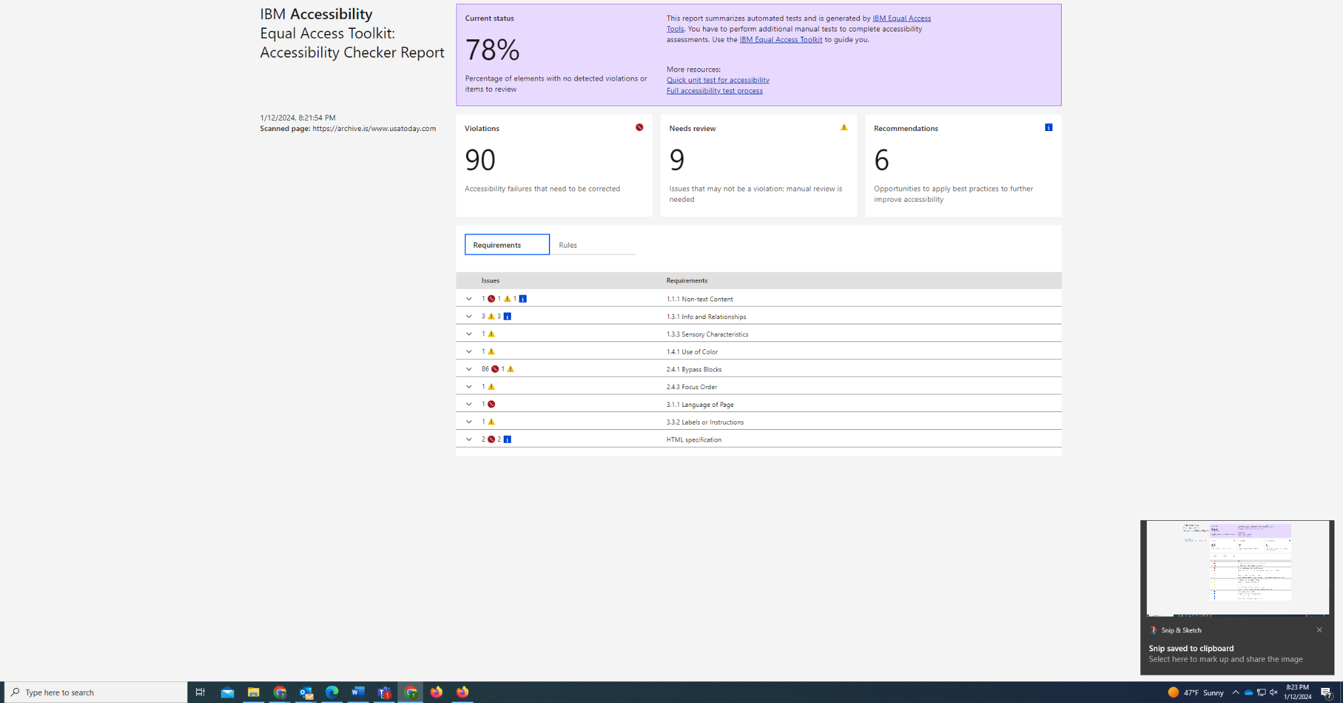

Axe:

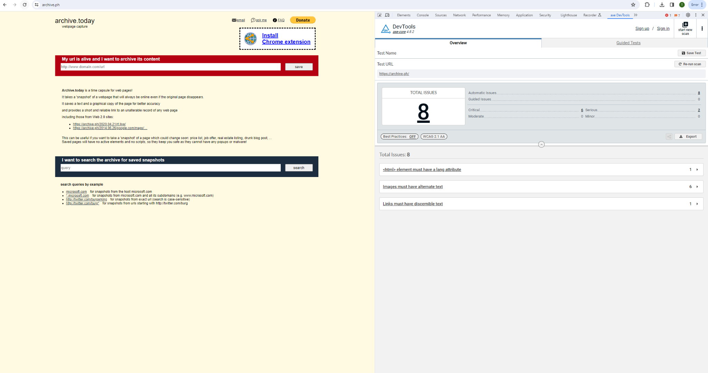

AI :

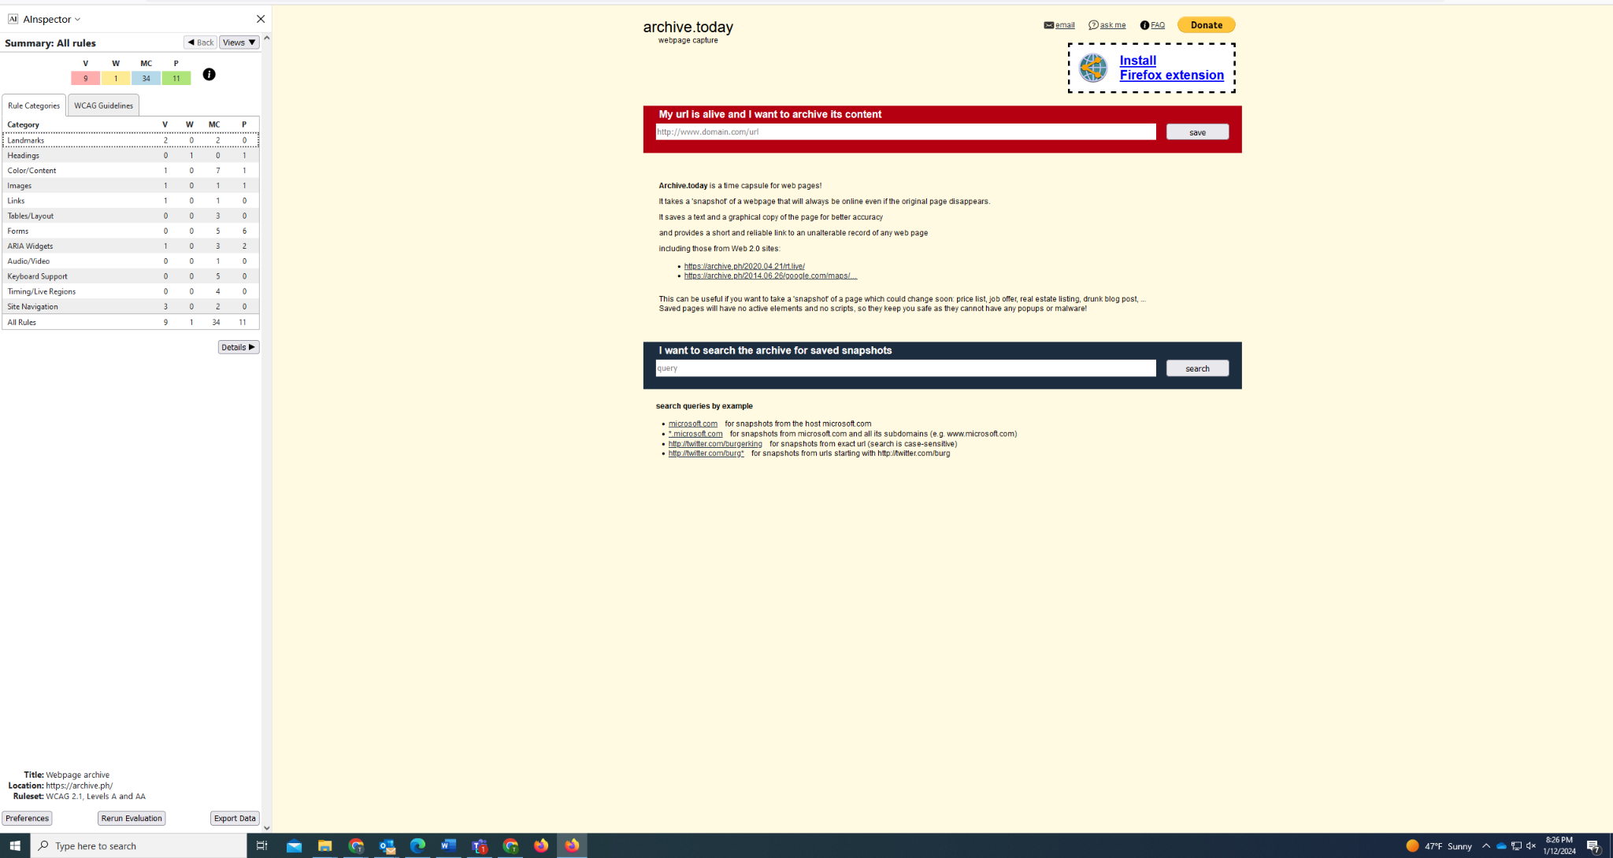

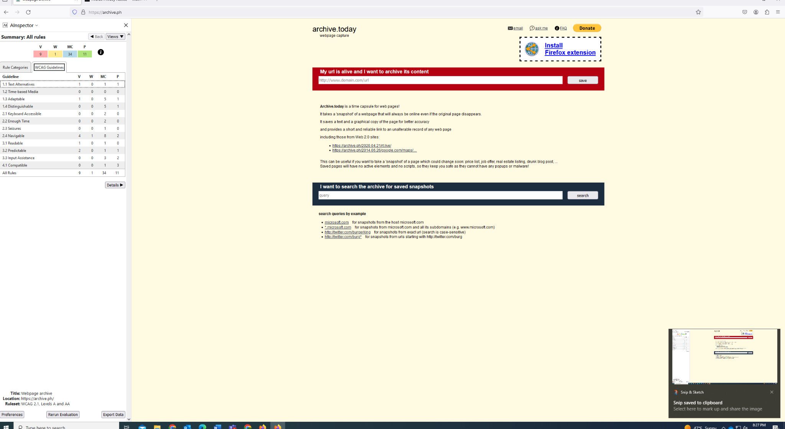

Link 2 wave : <https://archive.ph/20200421201055/https://rt.live/> 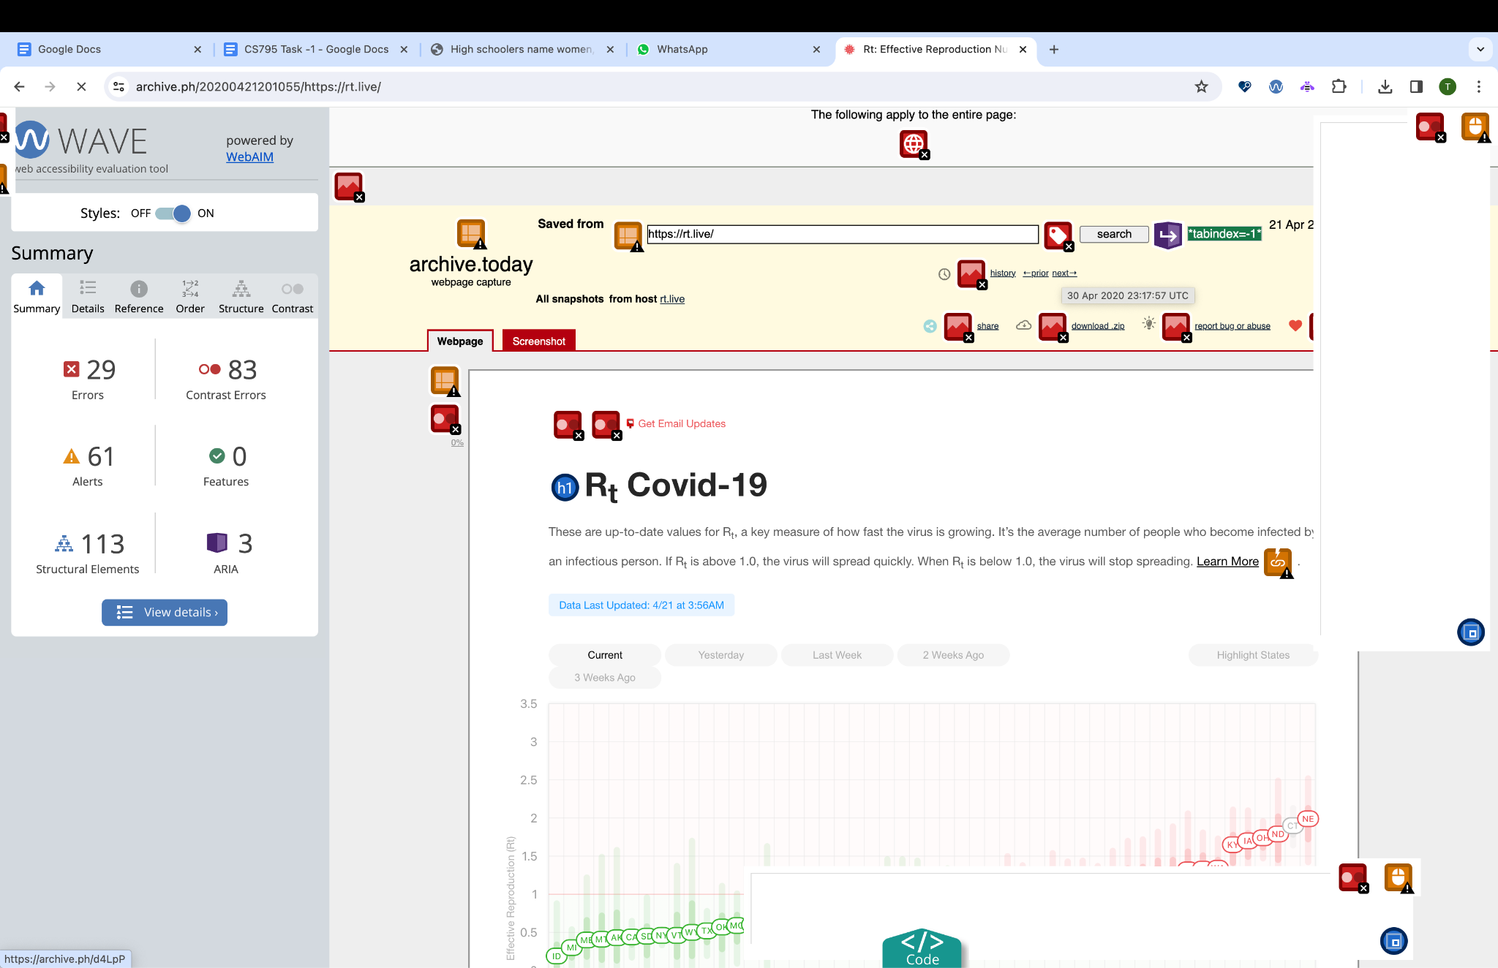

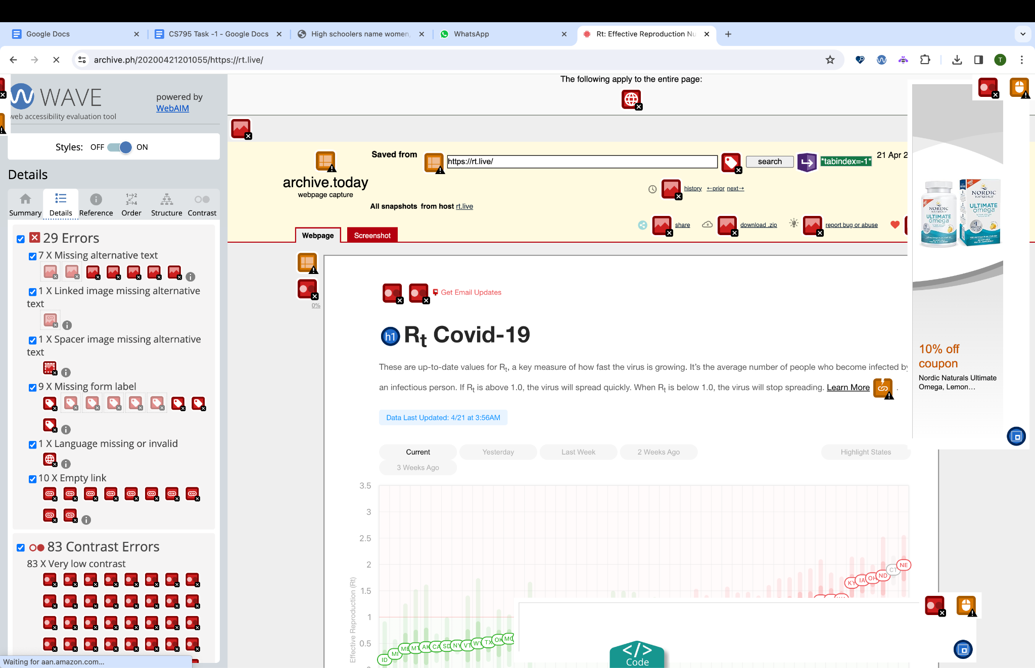

Link 3 : Wave : <https://archive.ph/20140626212928/https://www.google.com/maps/@-12.1858563,96.8293918,366m/data=!3m1!1e3>

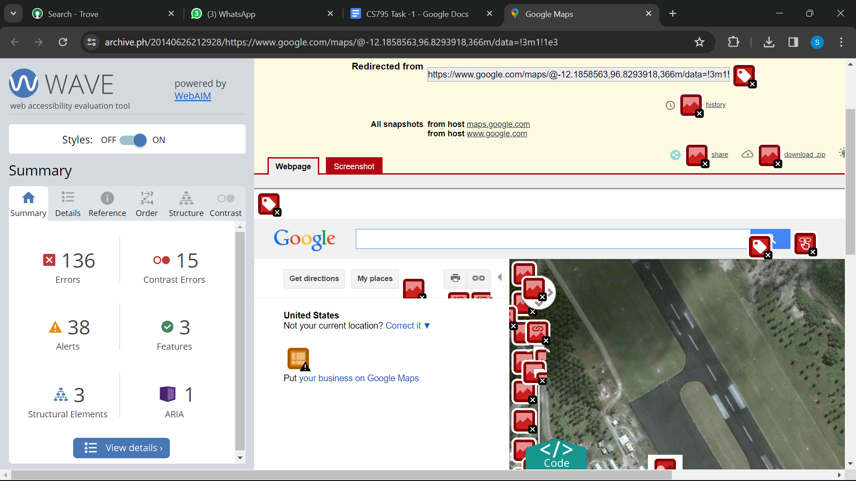

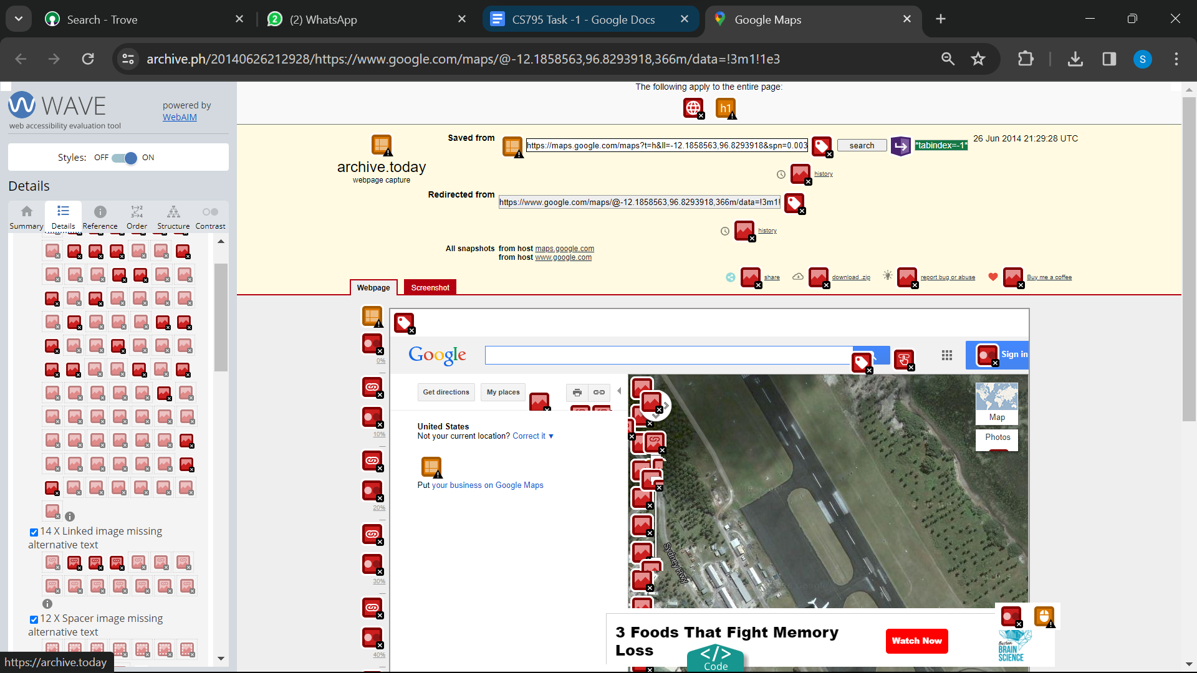

Link 4 : Wave <https://archive.is/www.usatoday.com>

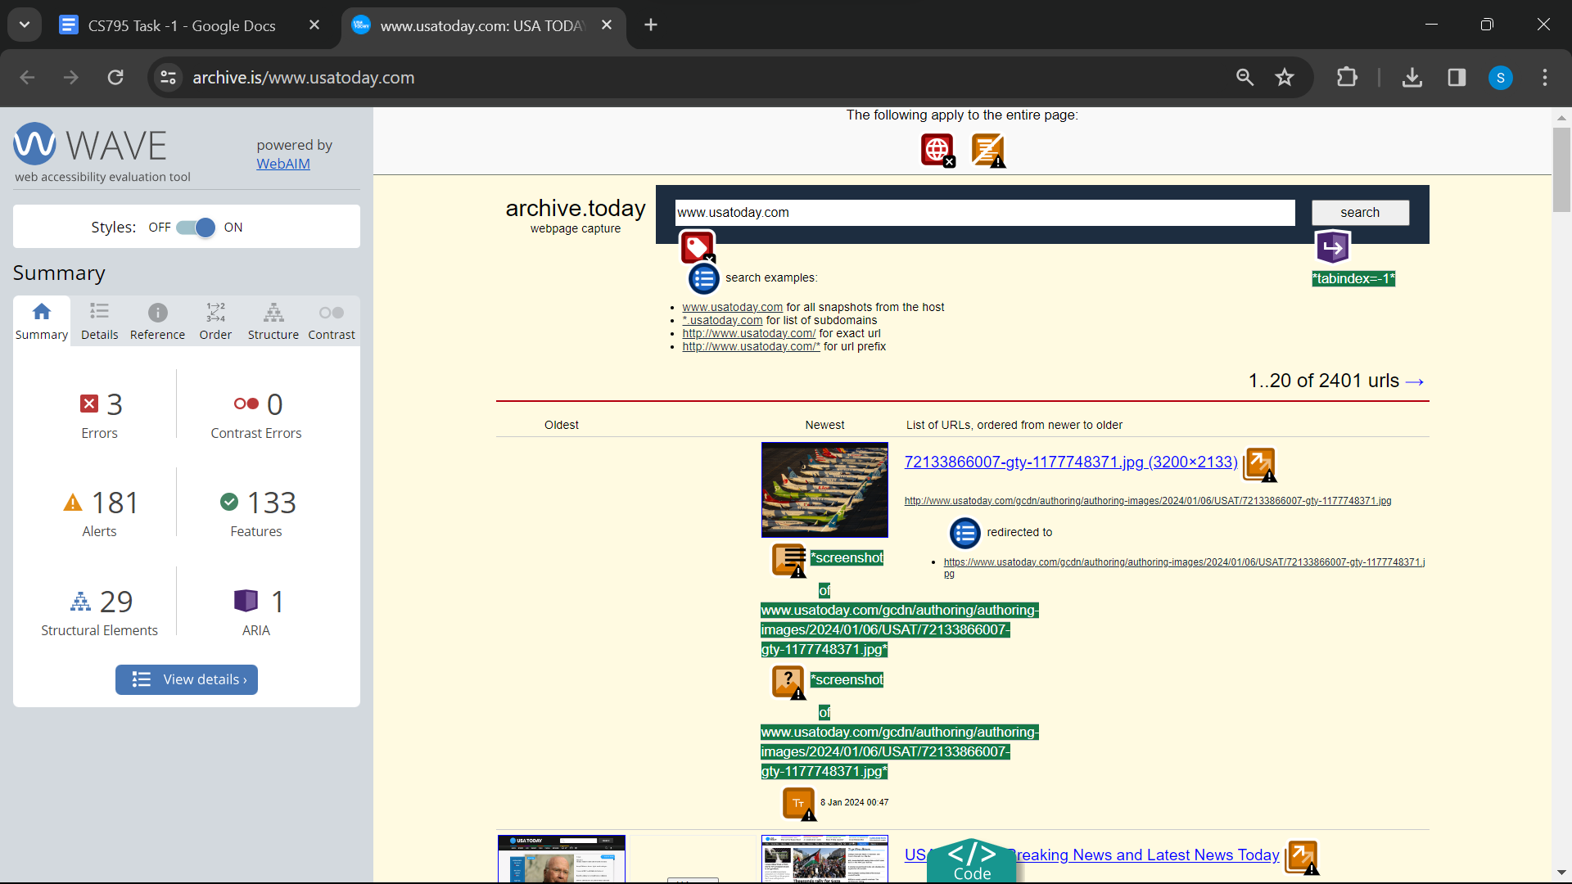

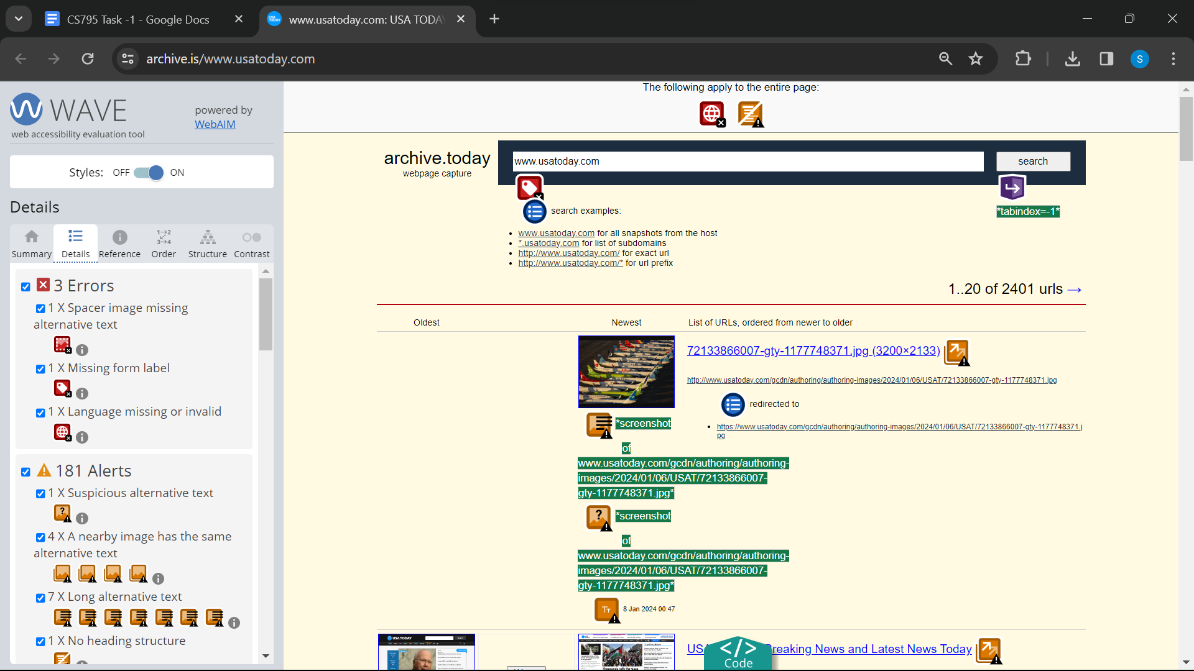

Link 5 : <https://archive.is/NWtsj>

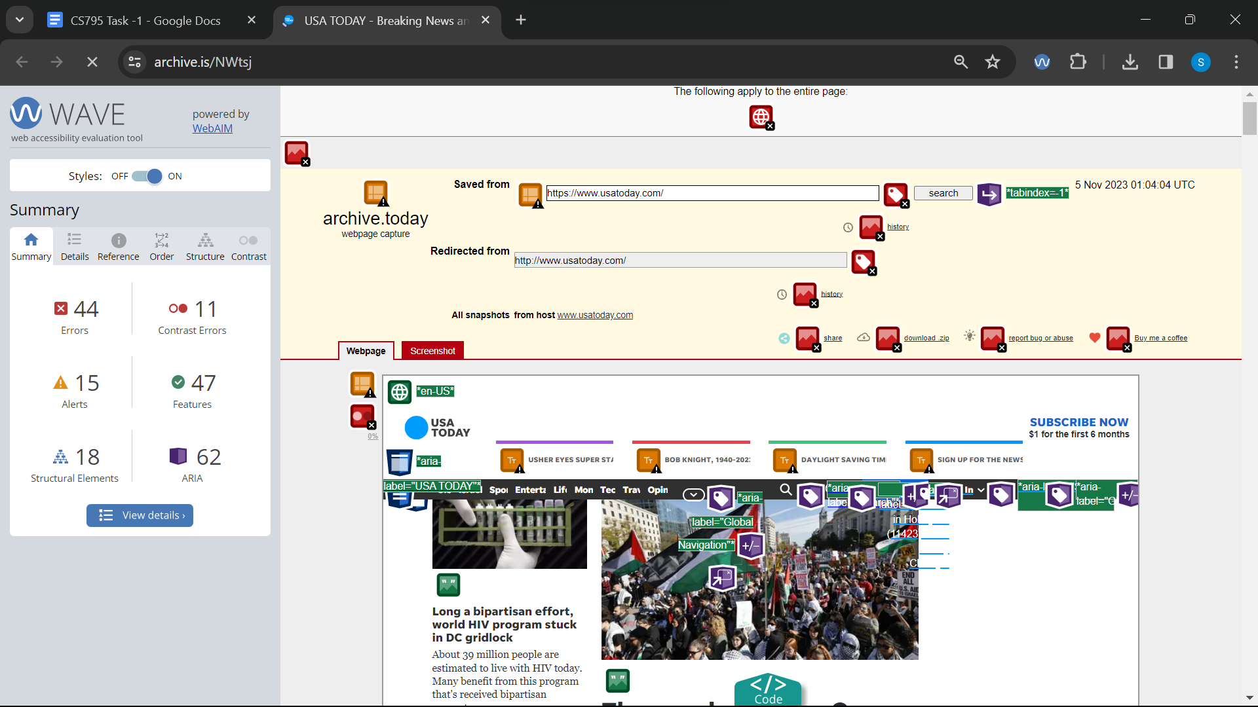

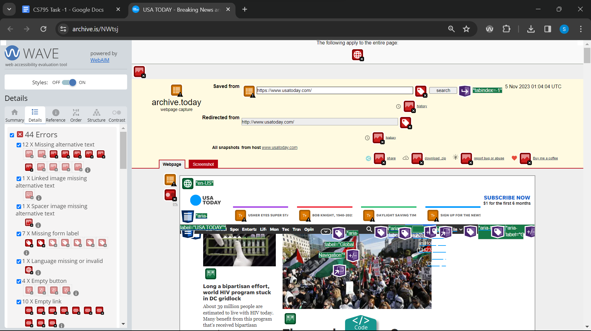

Link 6 : Wave : <https://archive.is/www.youtube.com>

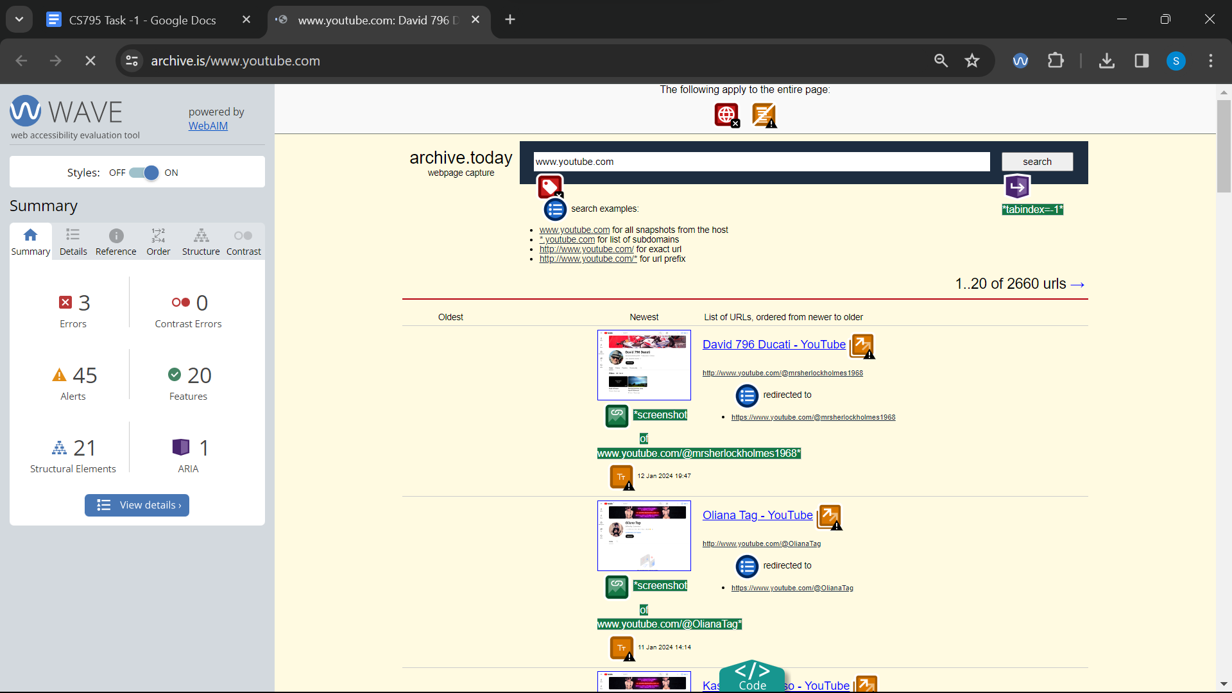

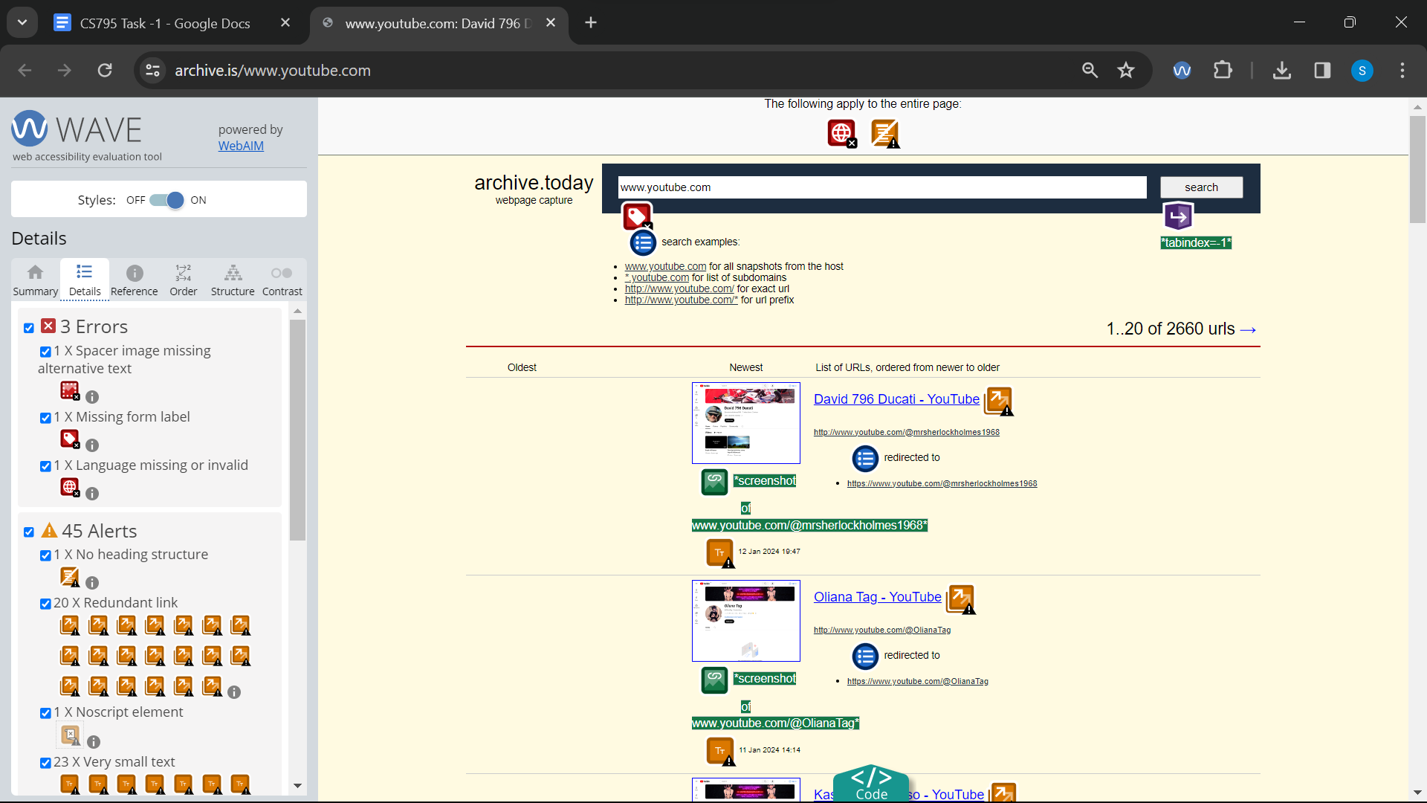

Link 7 : wave : <https://archive.is/btSNz>

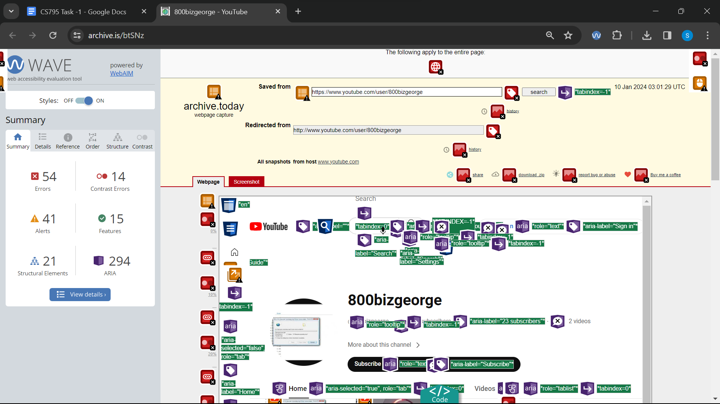

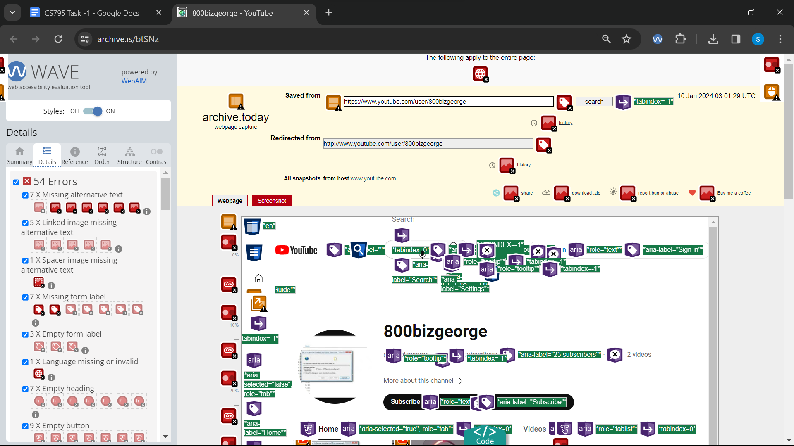

Link 8 : Wave: <https://archive.is/www.cnn.com>

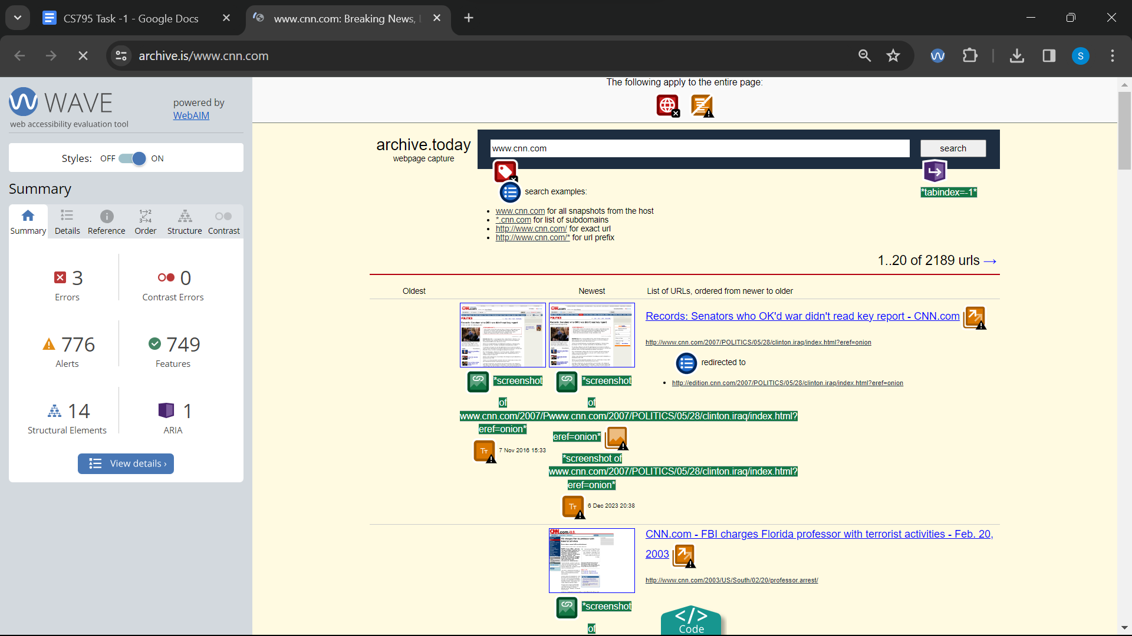

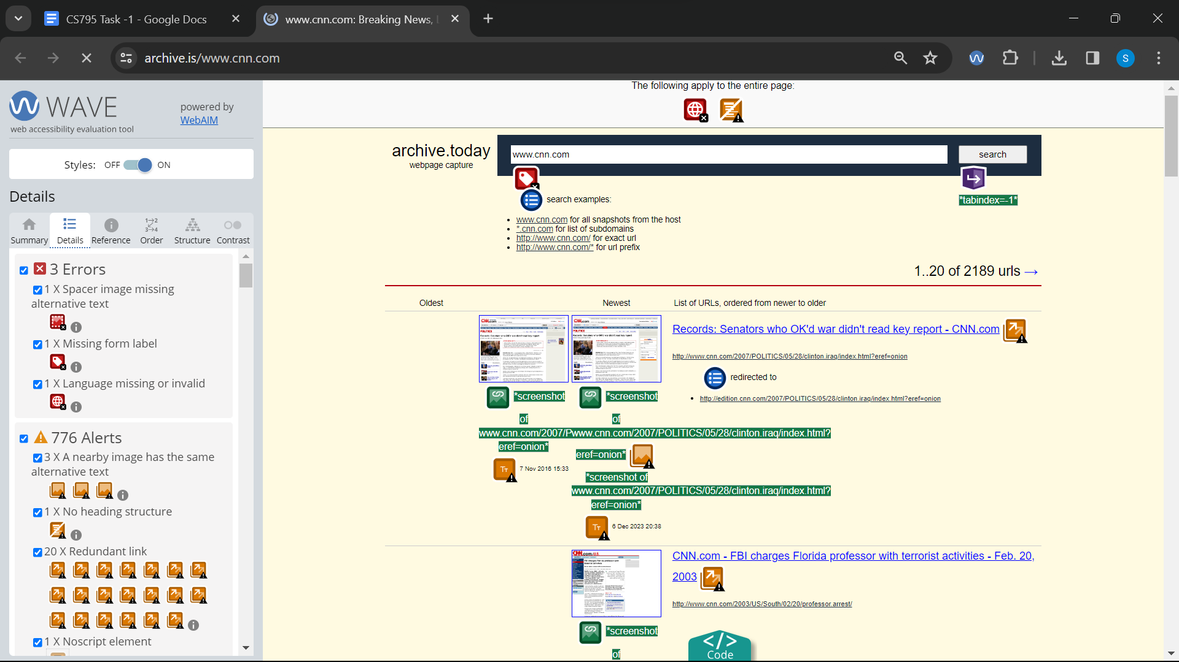

Link 9 : Wave : <https://archive.is/amFiR>

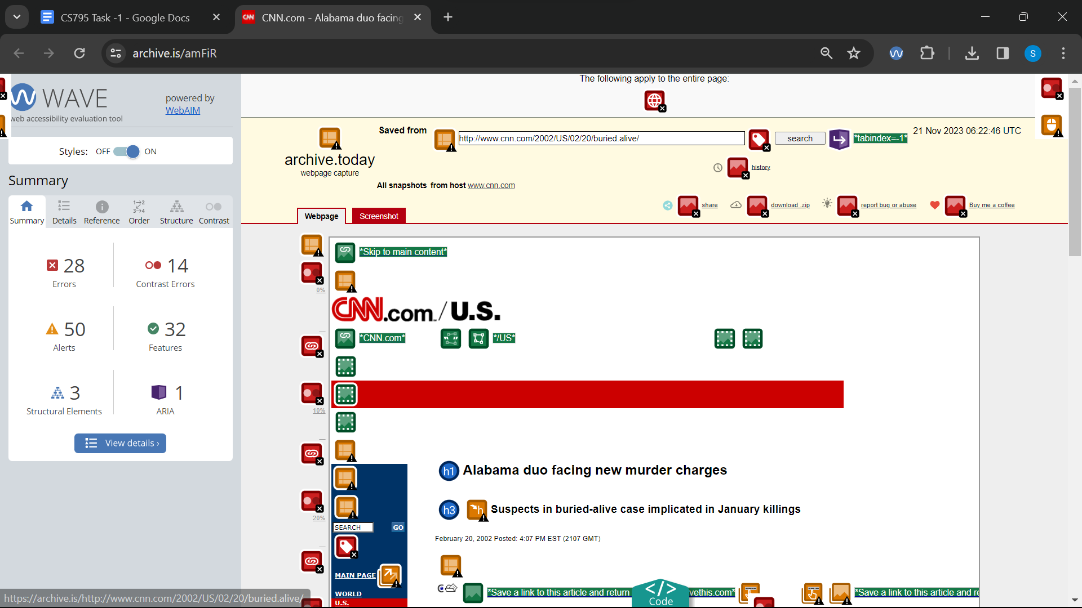

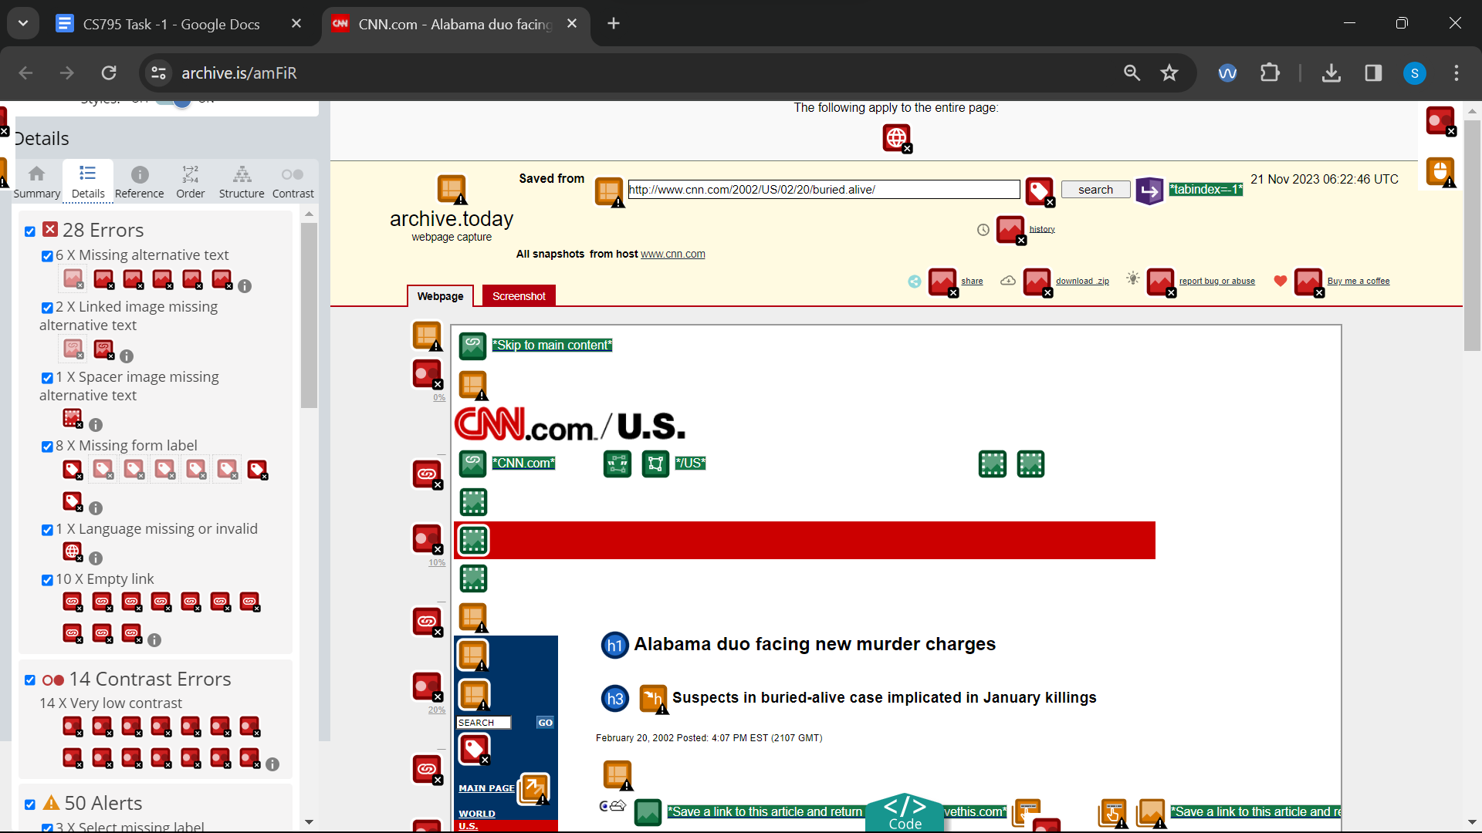

Link 10 : Wave : <https://archive.is/www.dominos.com>

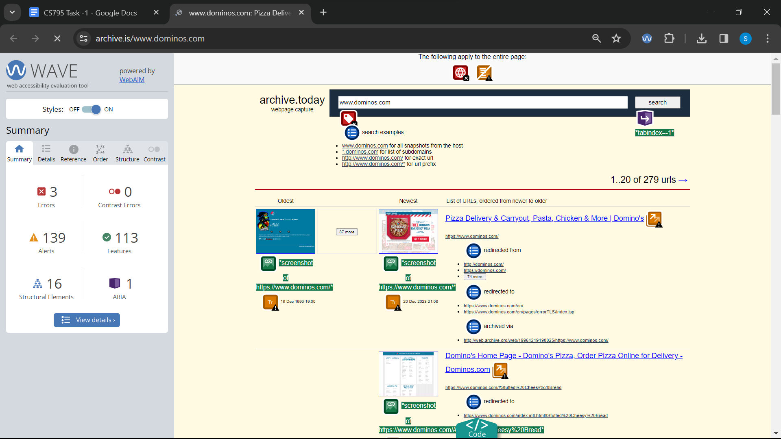

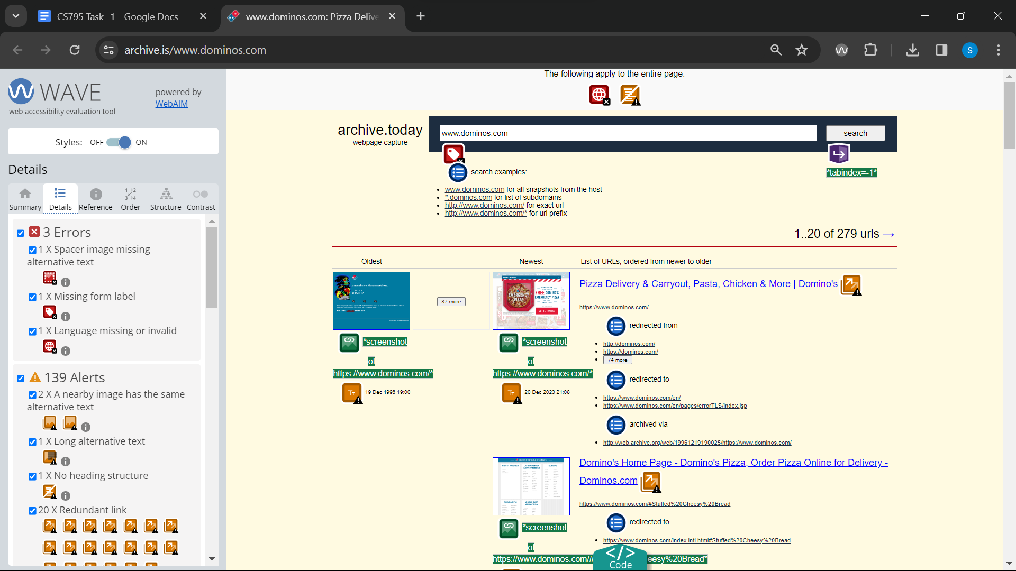

Link 11 : Wave : <https://archive.is/W2uf0>

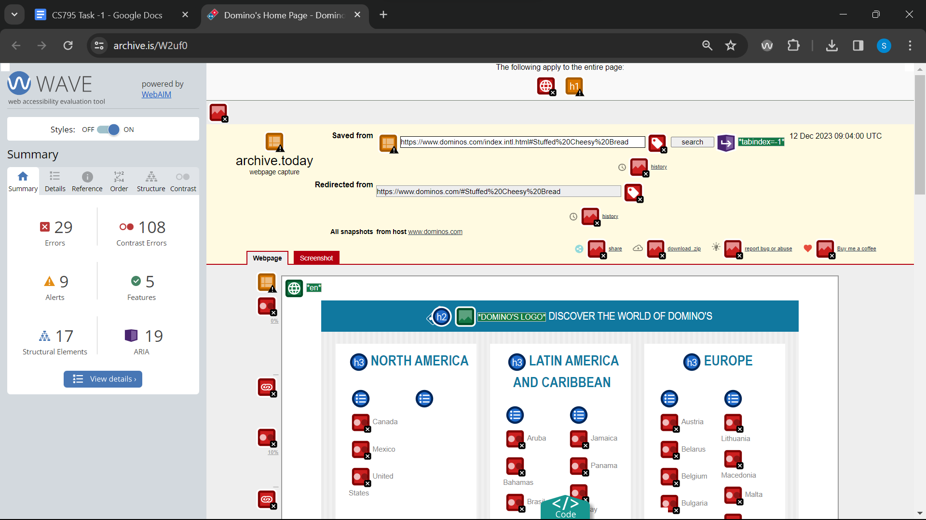

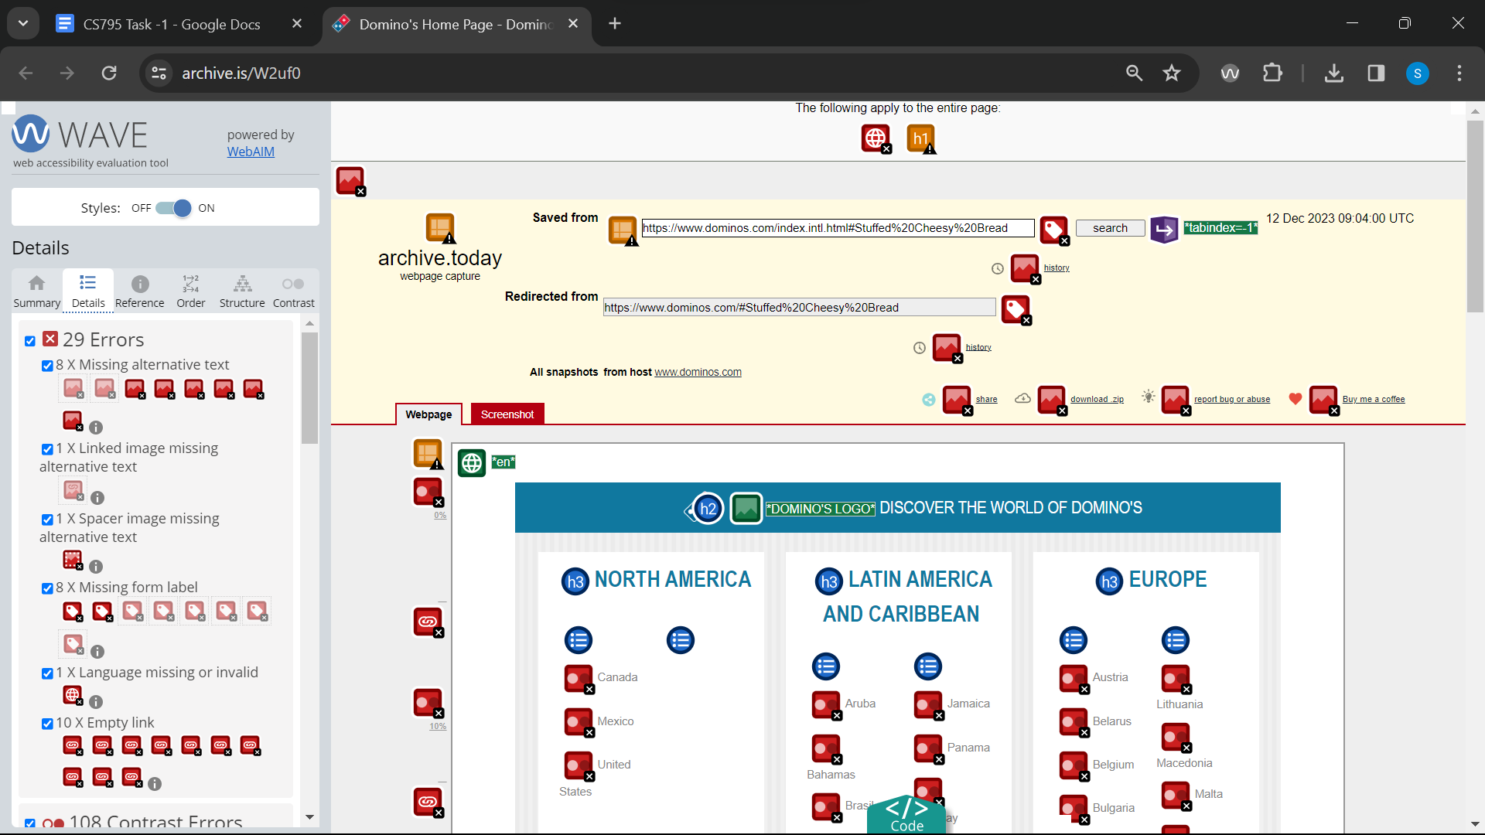

Link 12 : Wave : [https://archive.ph/*.microsoft.com](https://archive.ph/*.microsoft.com)

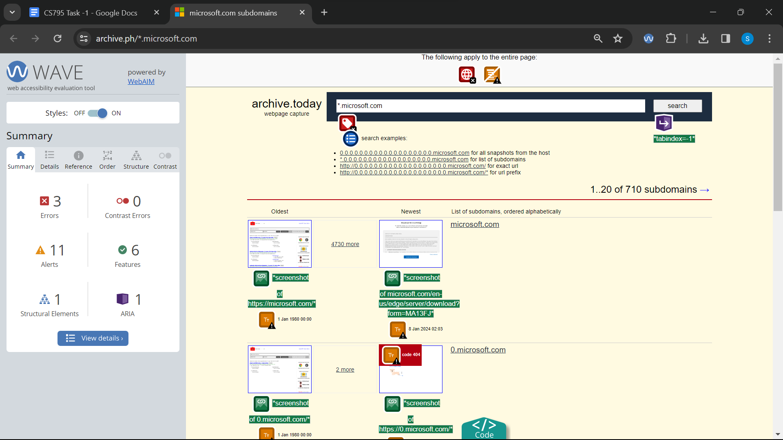

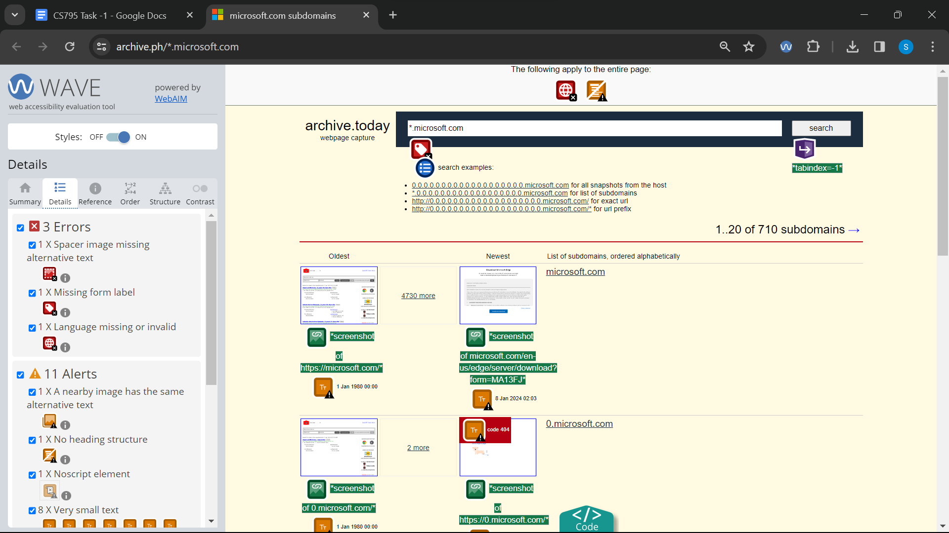

Link 13 : Wave : <https://archive.ph/0.0.microsoft.com>

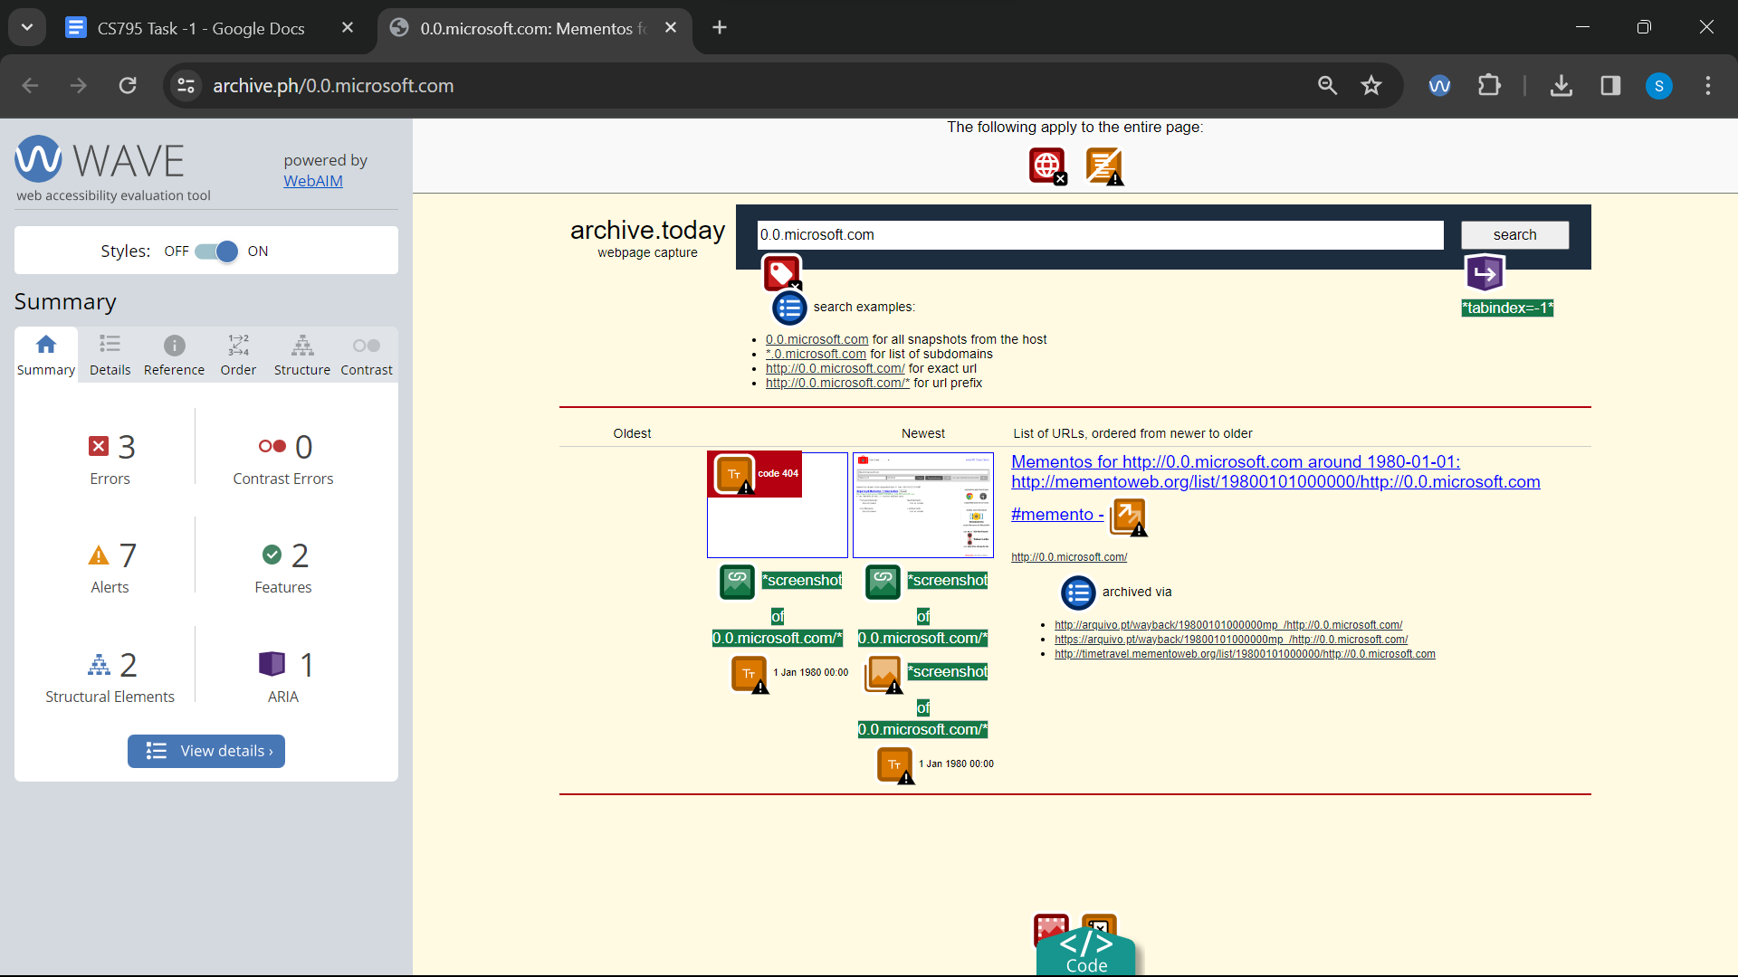

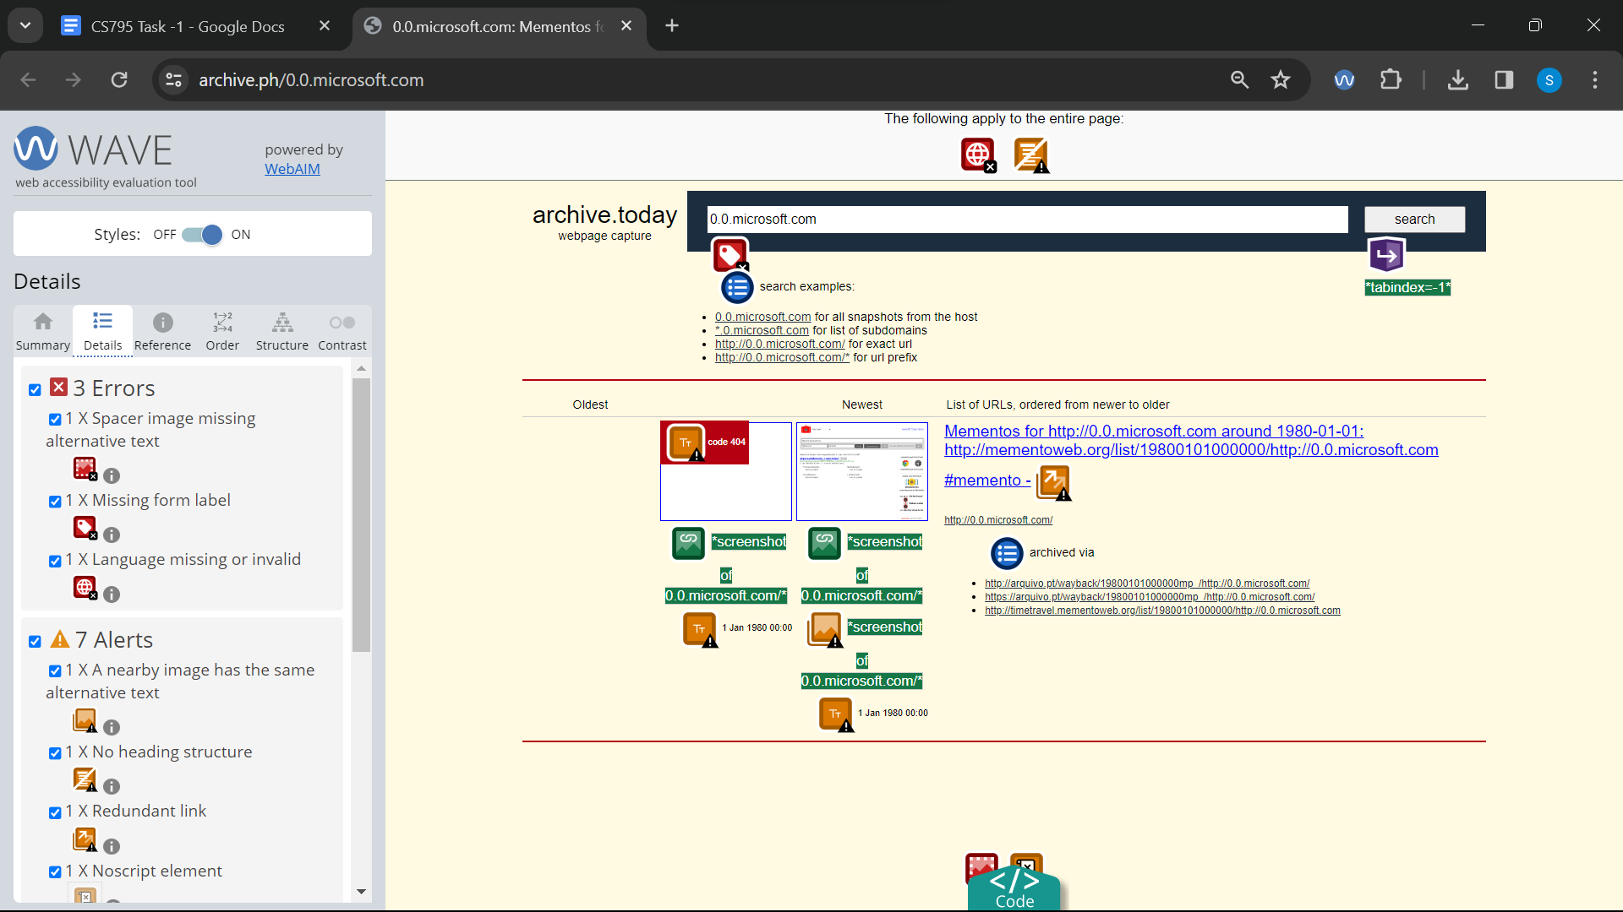

Link 14 : Wave : <https://archive.ph/MR6xP>

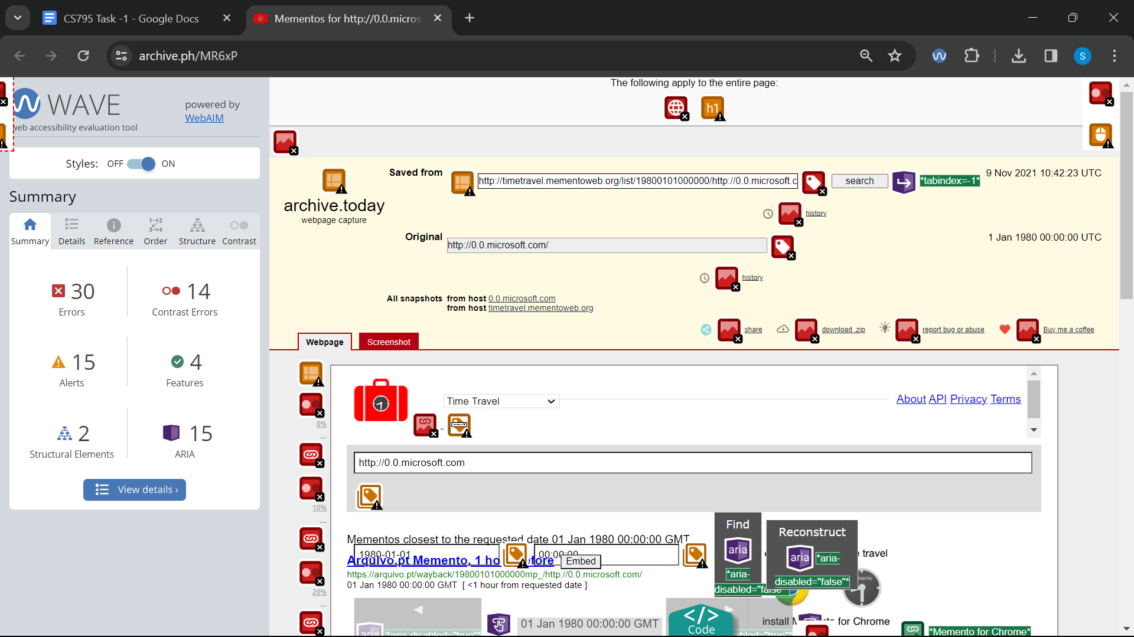

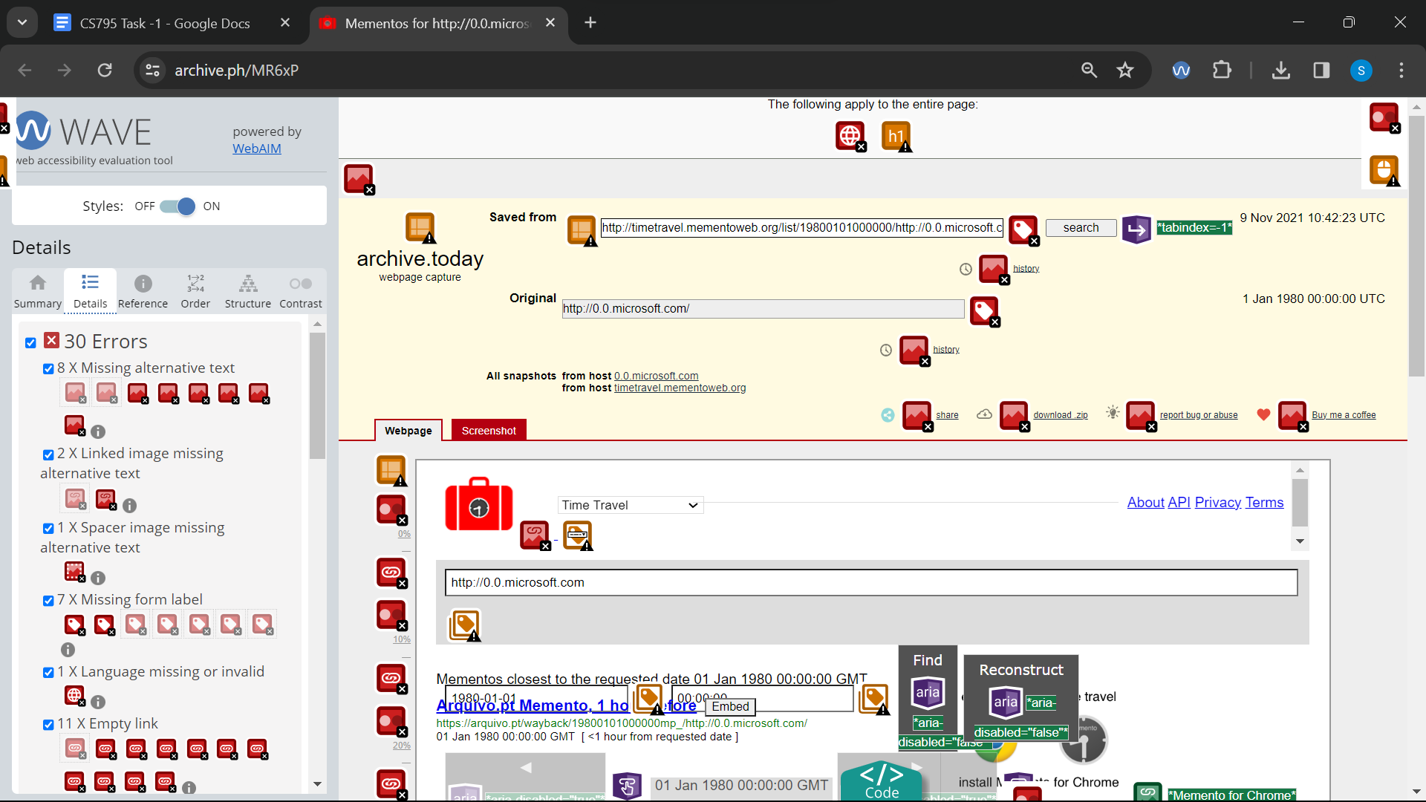

Link 15 : Wave :<https://archive.is/www.indiatoday.com>

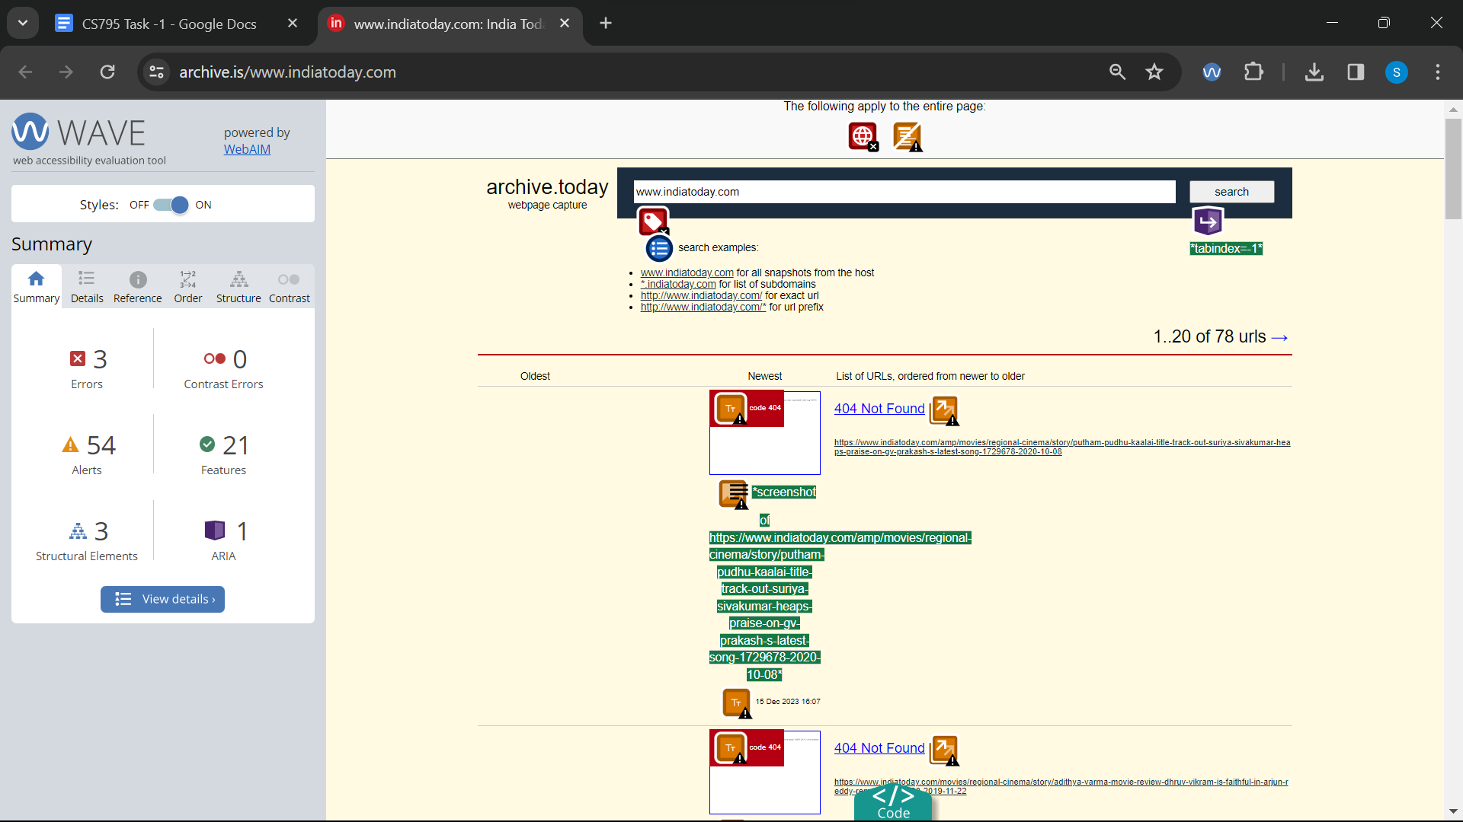

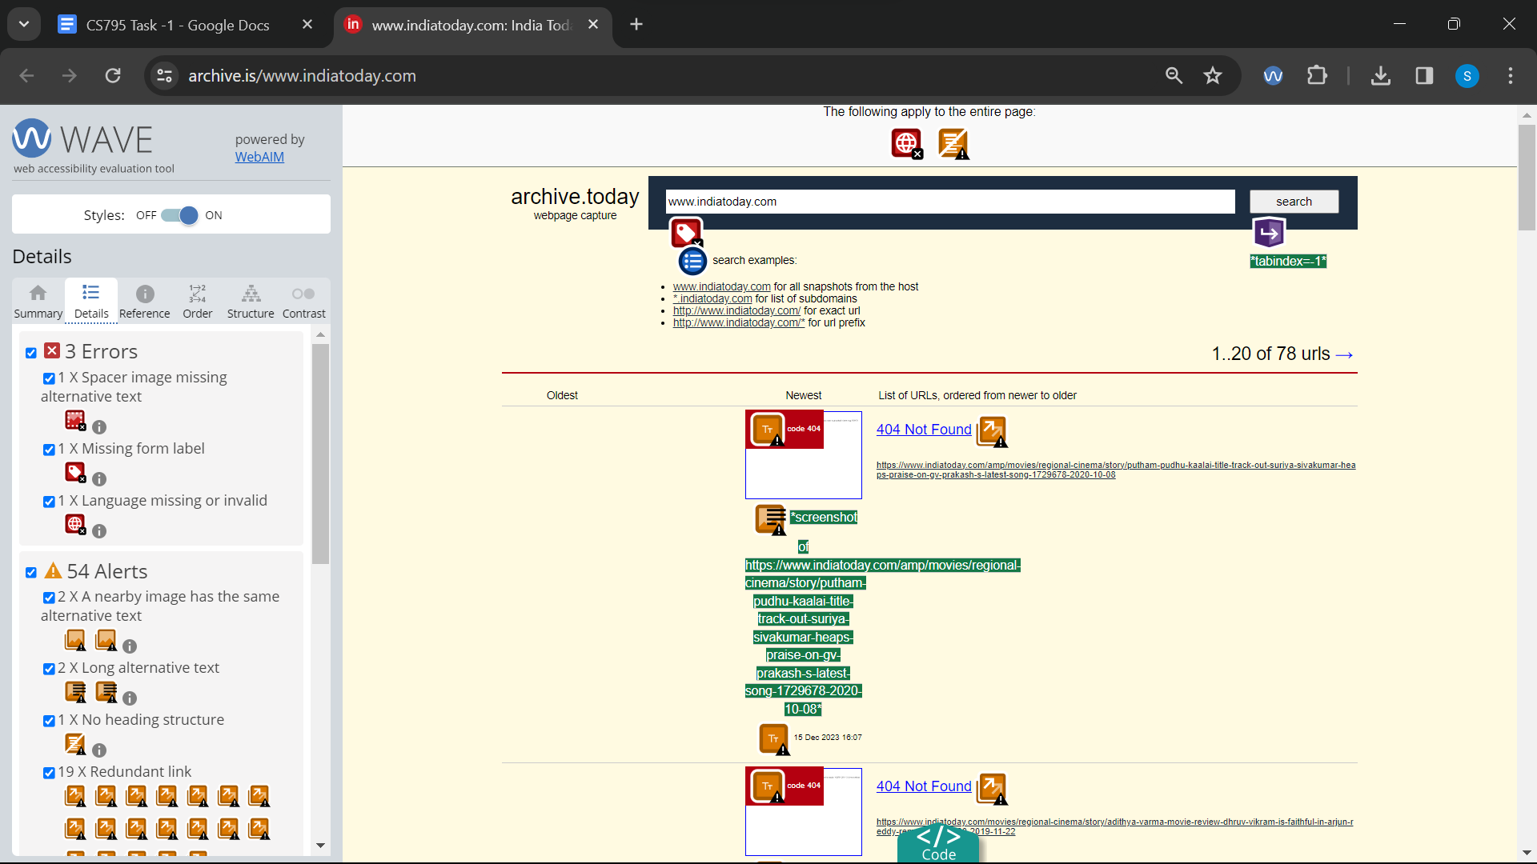

Link 16 : Wave :<https://archive.is/wYNt6>

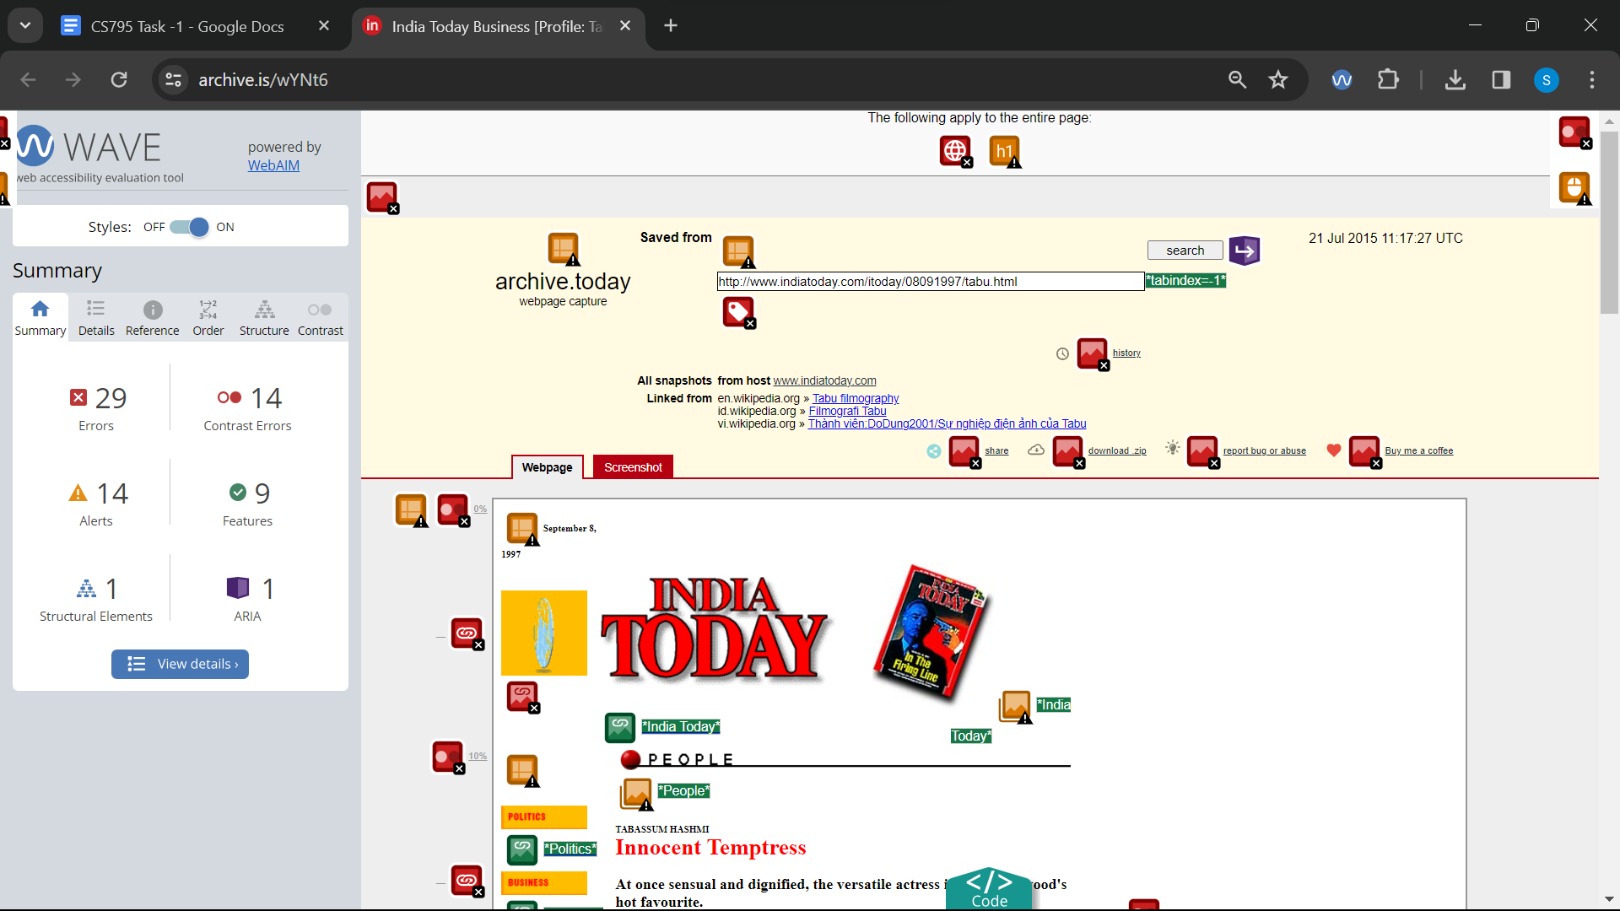

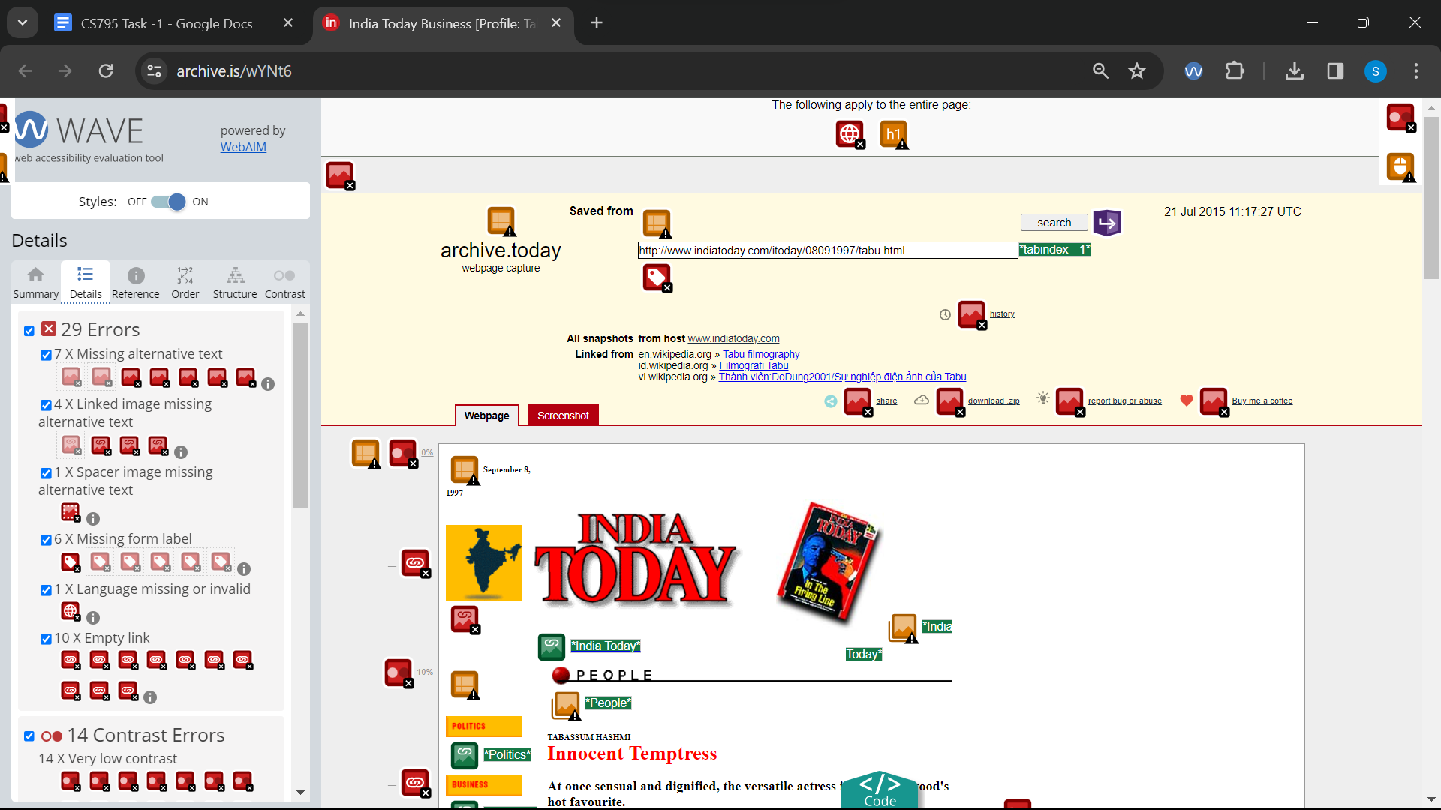

Link 17 : Wave :<https://archive.is/www.github.com>

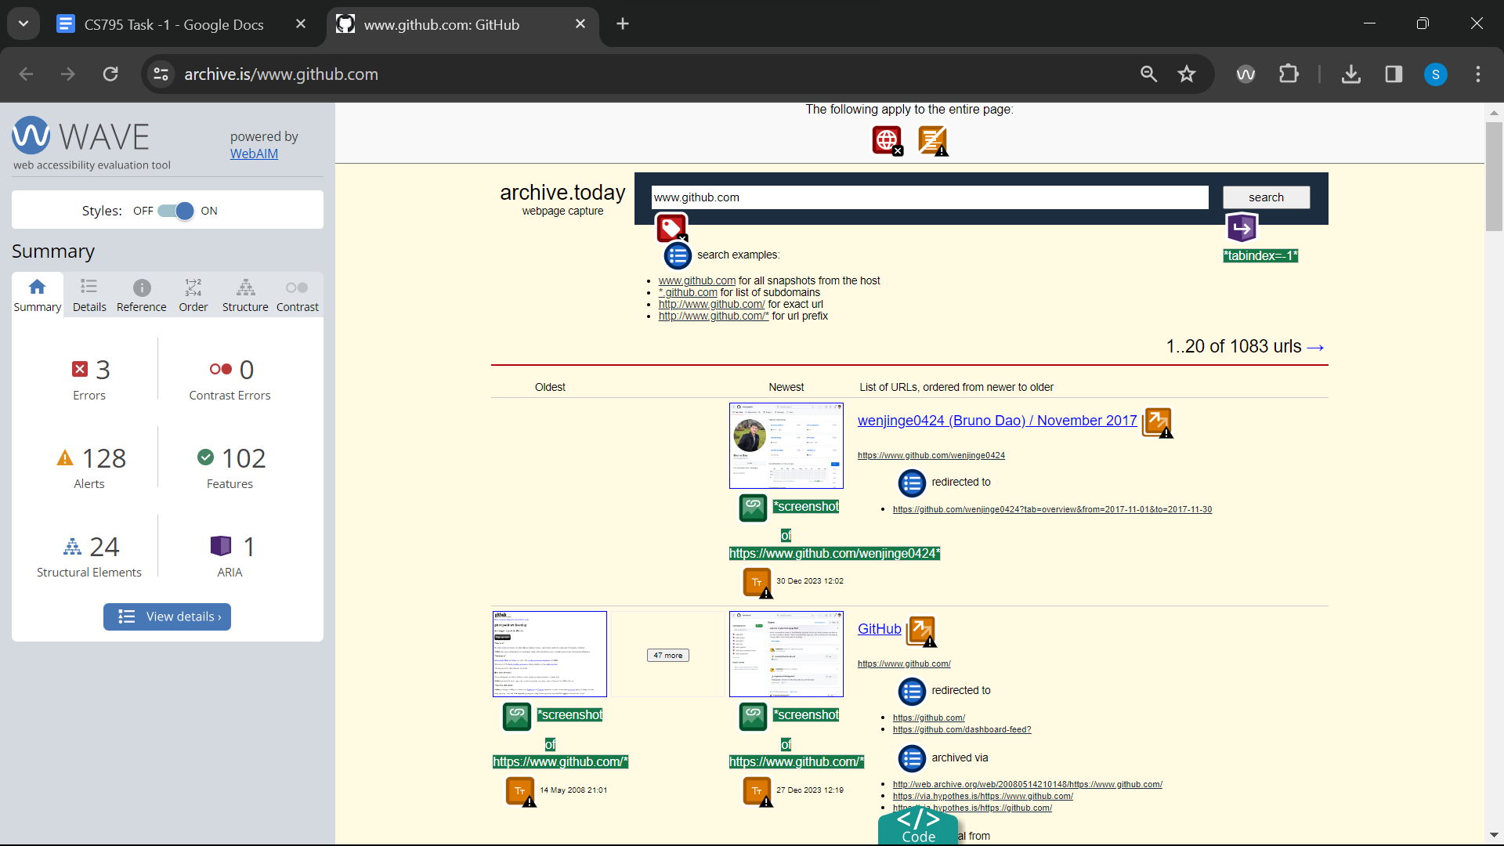

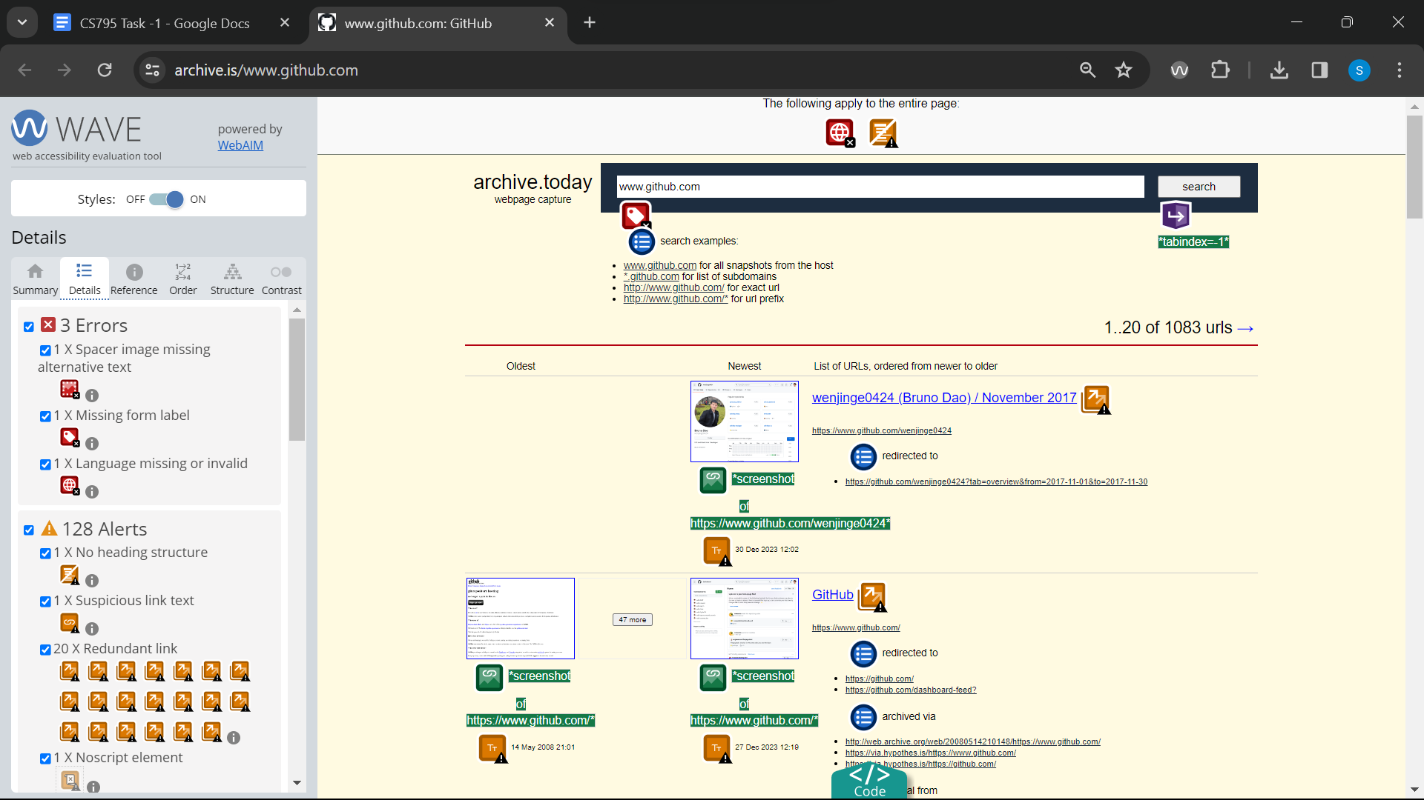

Link 18 : Wave : <https://archive.is/eOx7L>

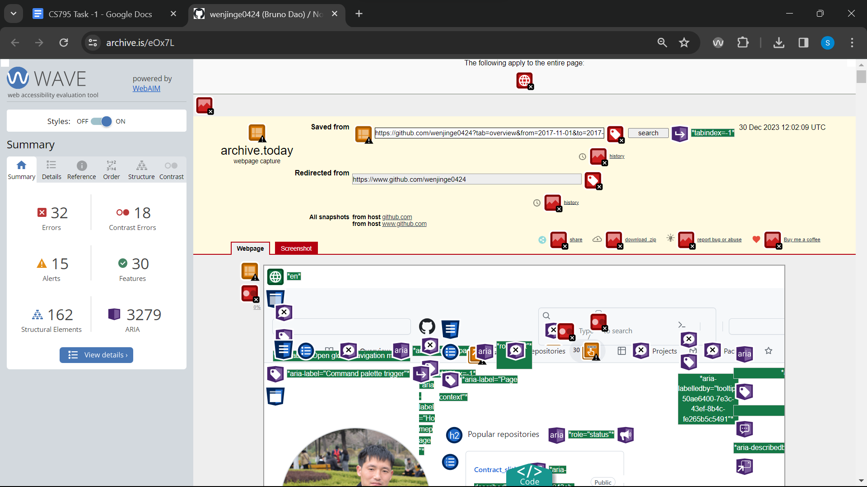

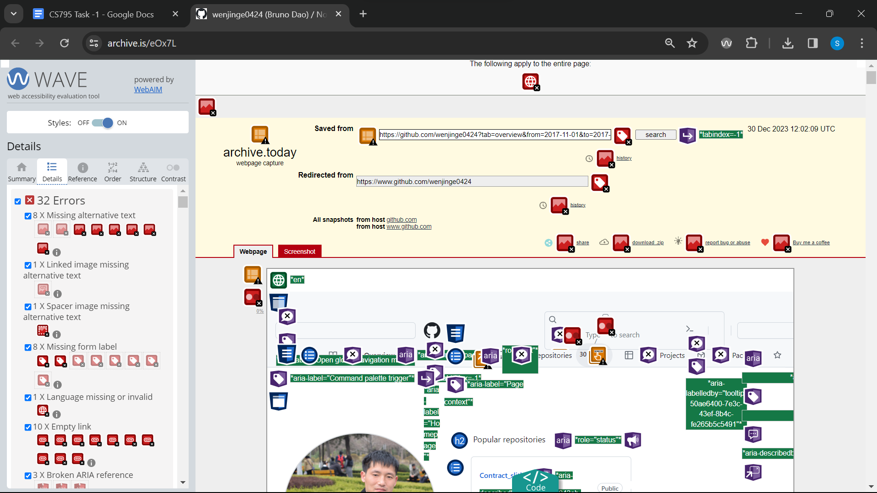

Link 19 : Wave :<https://archive.is/www.yahoo.com>

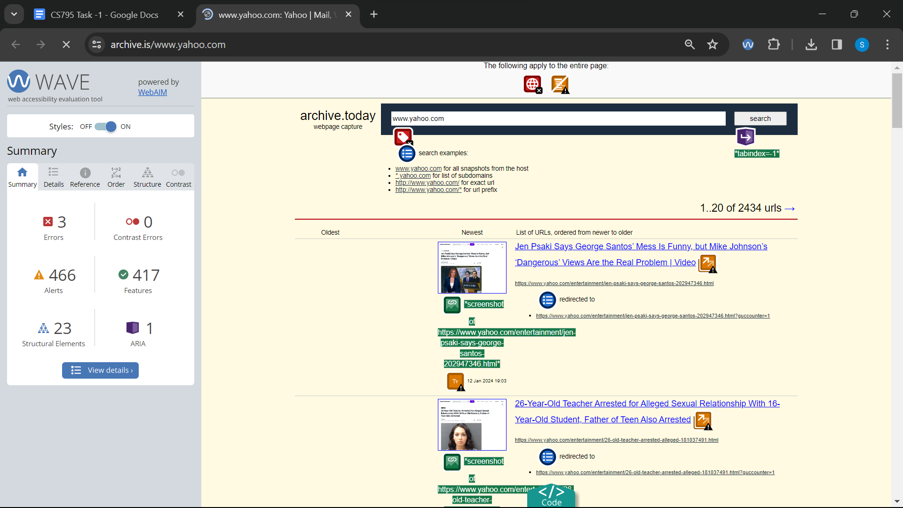

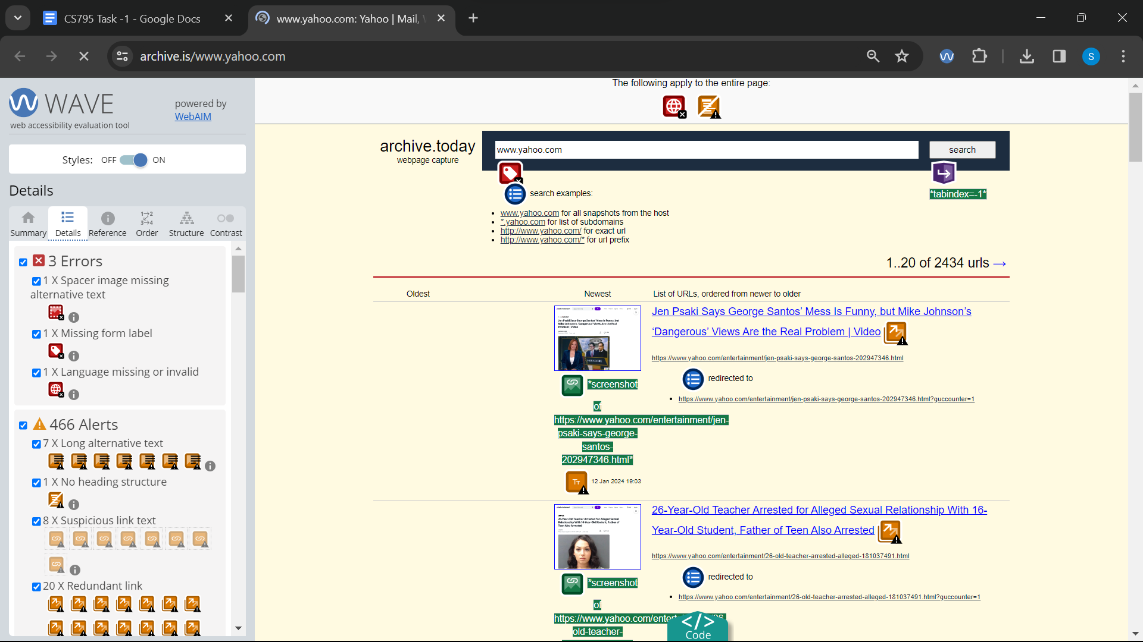

Link 20 : Wave :<https://archive.is/bEzdt>

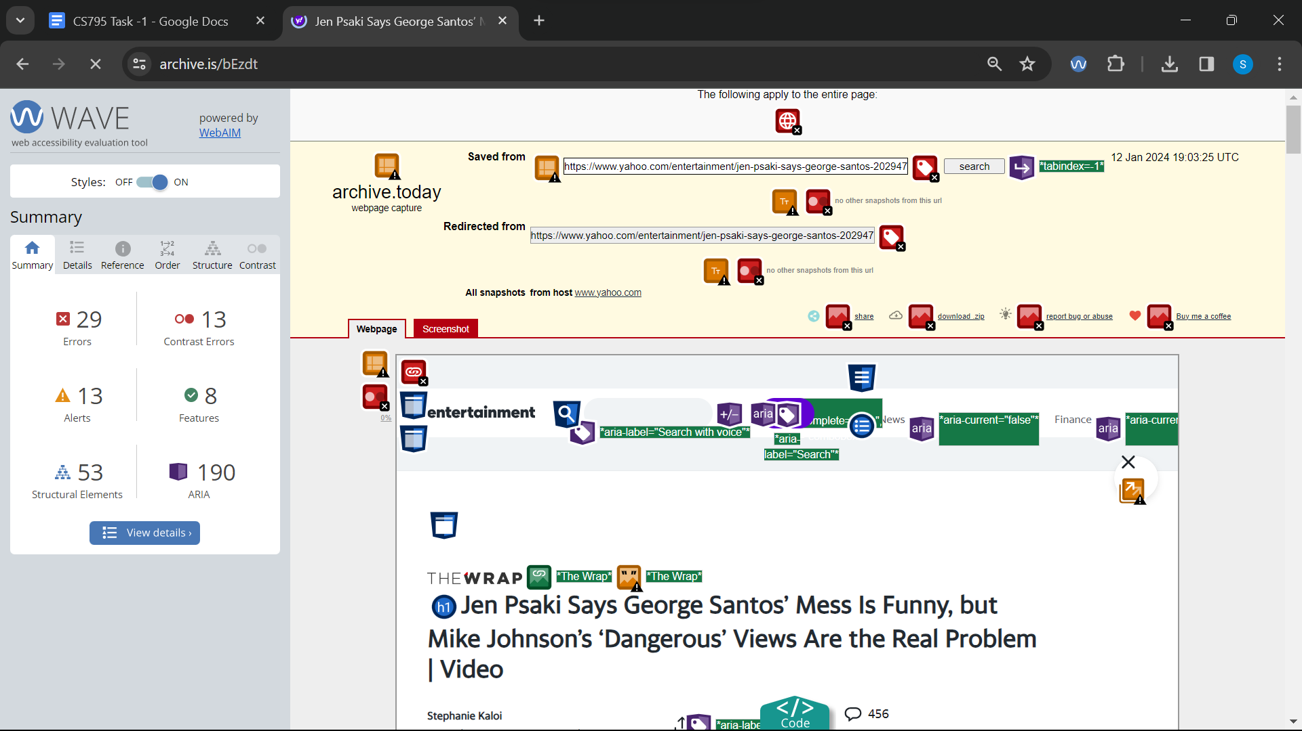

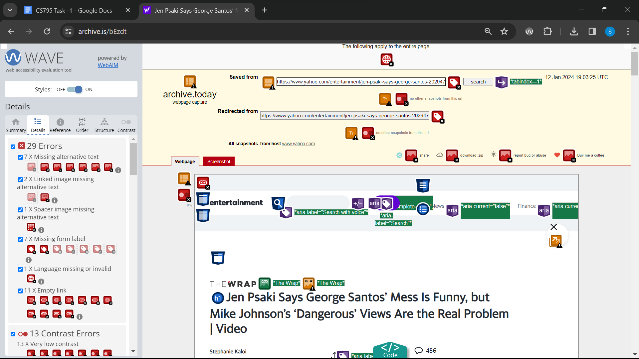

Link 21 : Wave :<https://archive.is/u7pQx>

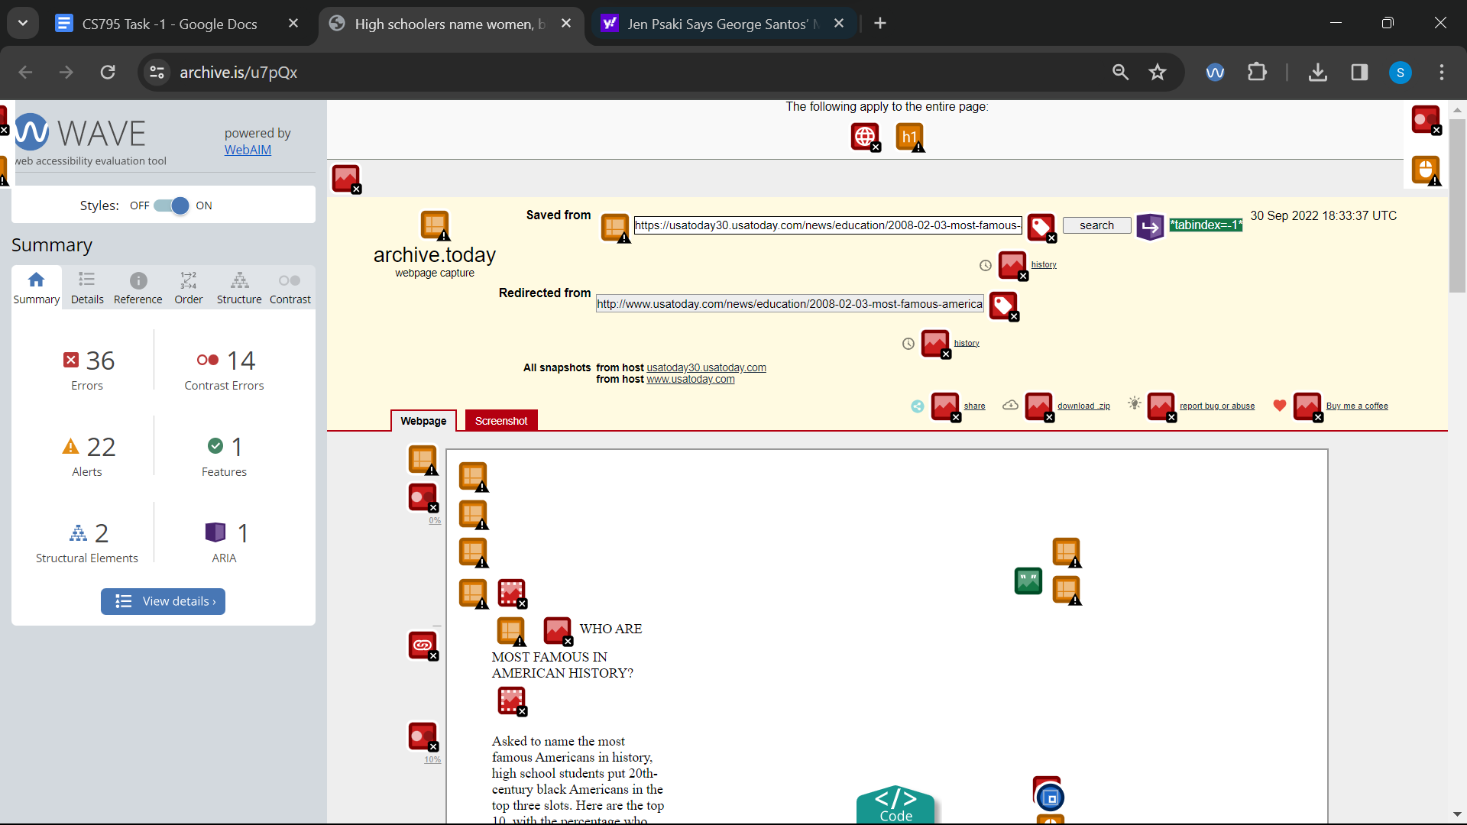

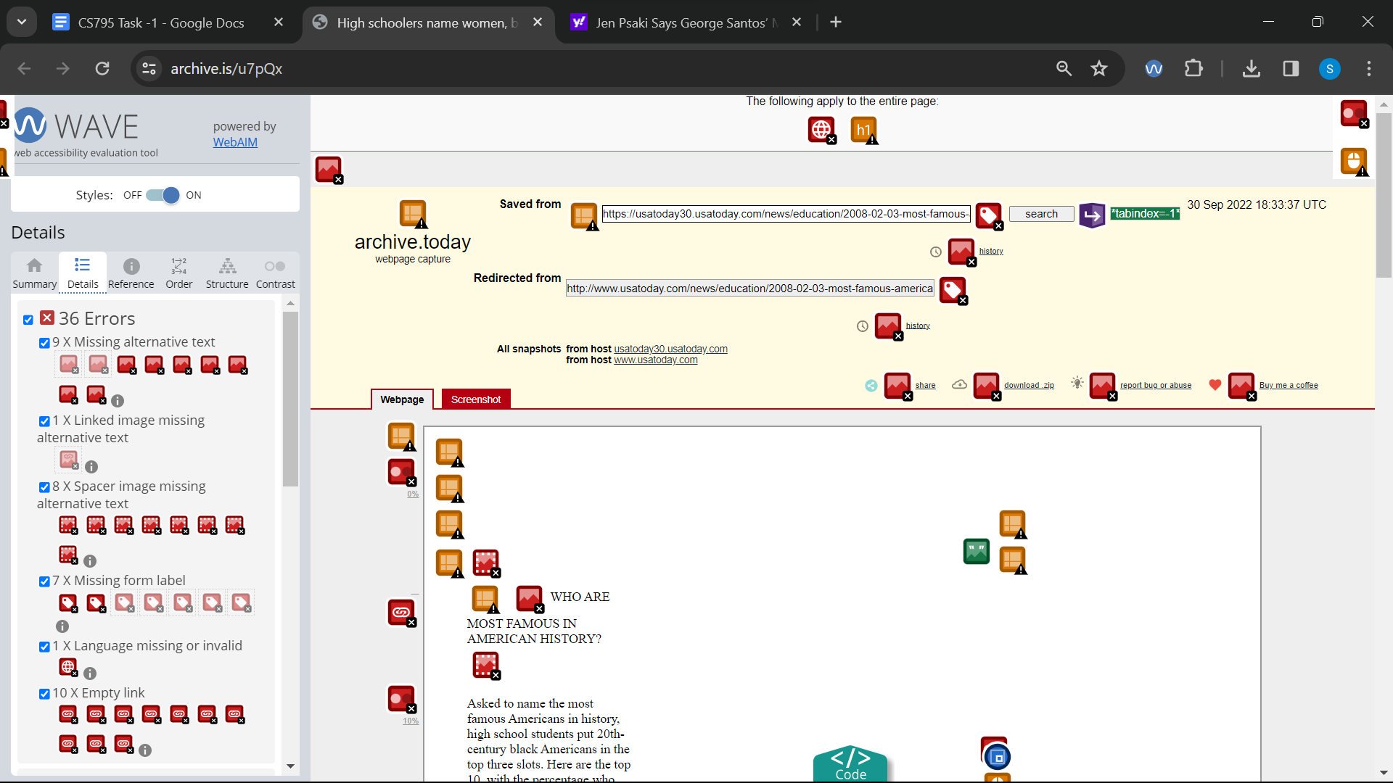

Link 22 : Wave : <https://archive.is/www.cocacola.com>

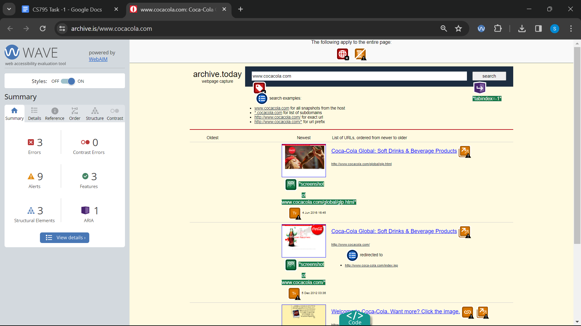

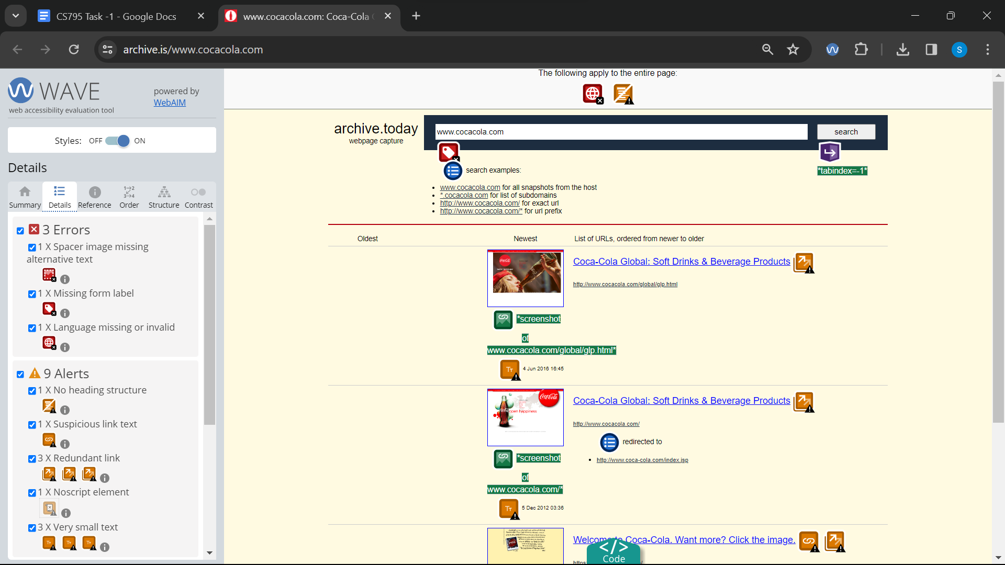

Link 23 : Wave : <https://archive.is/1ScQd>

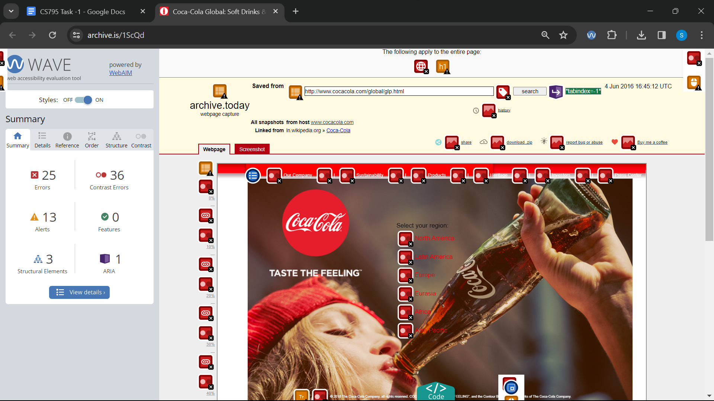

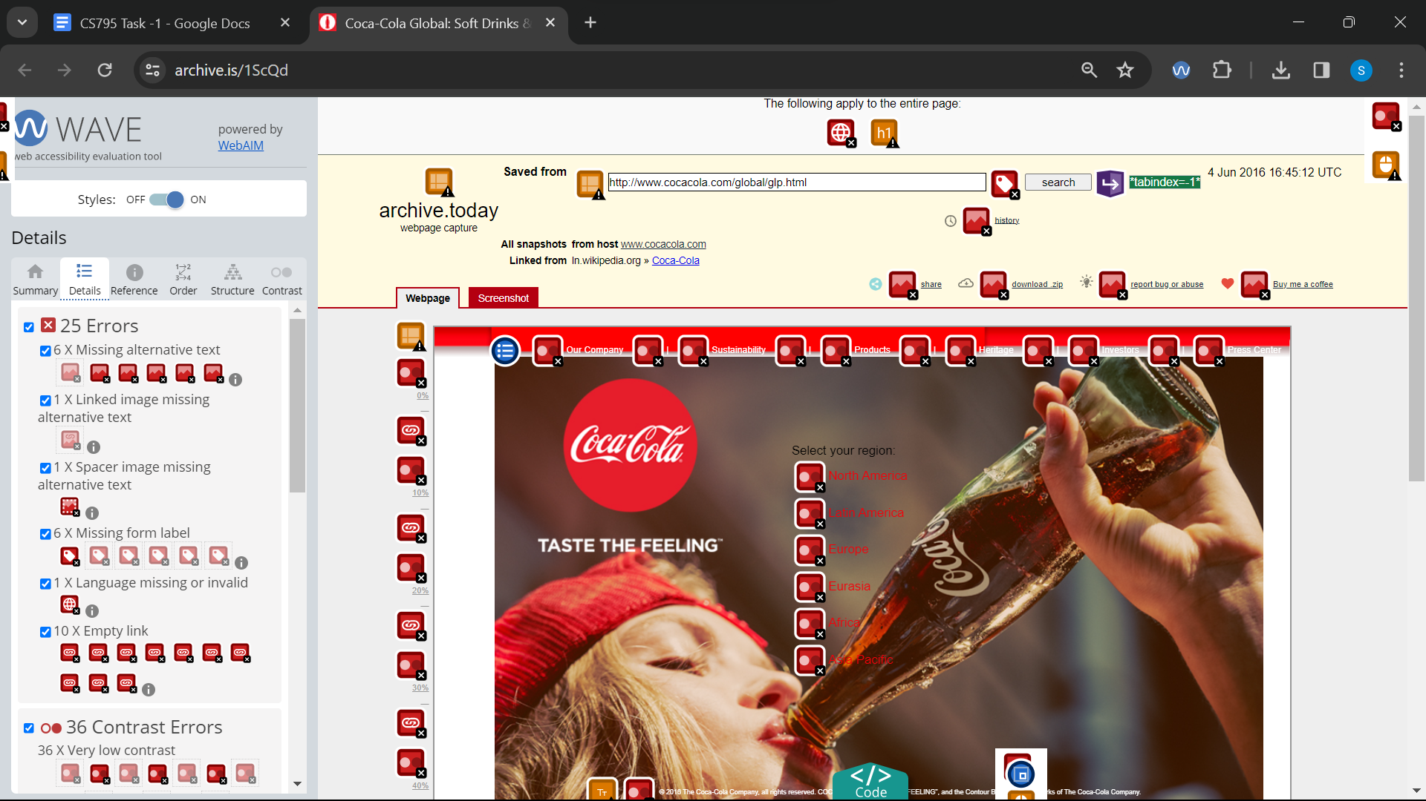

Link 24 : Wave :<https://archive.is/u7pQx/image>

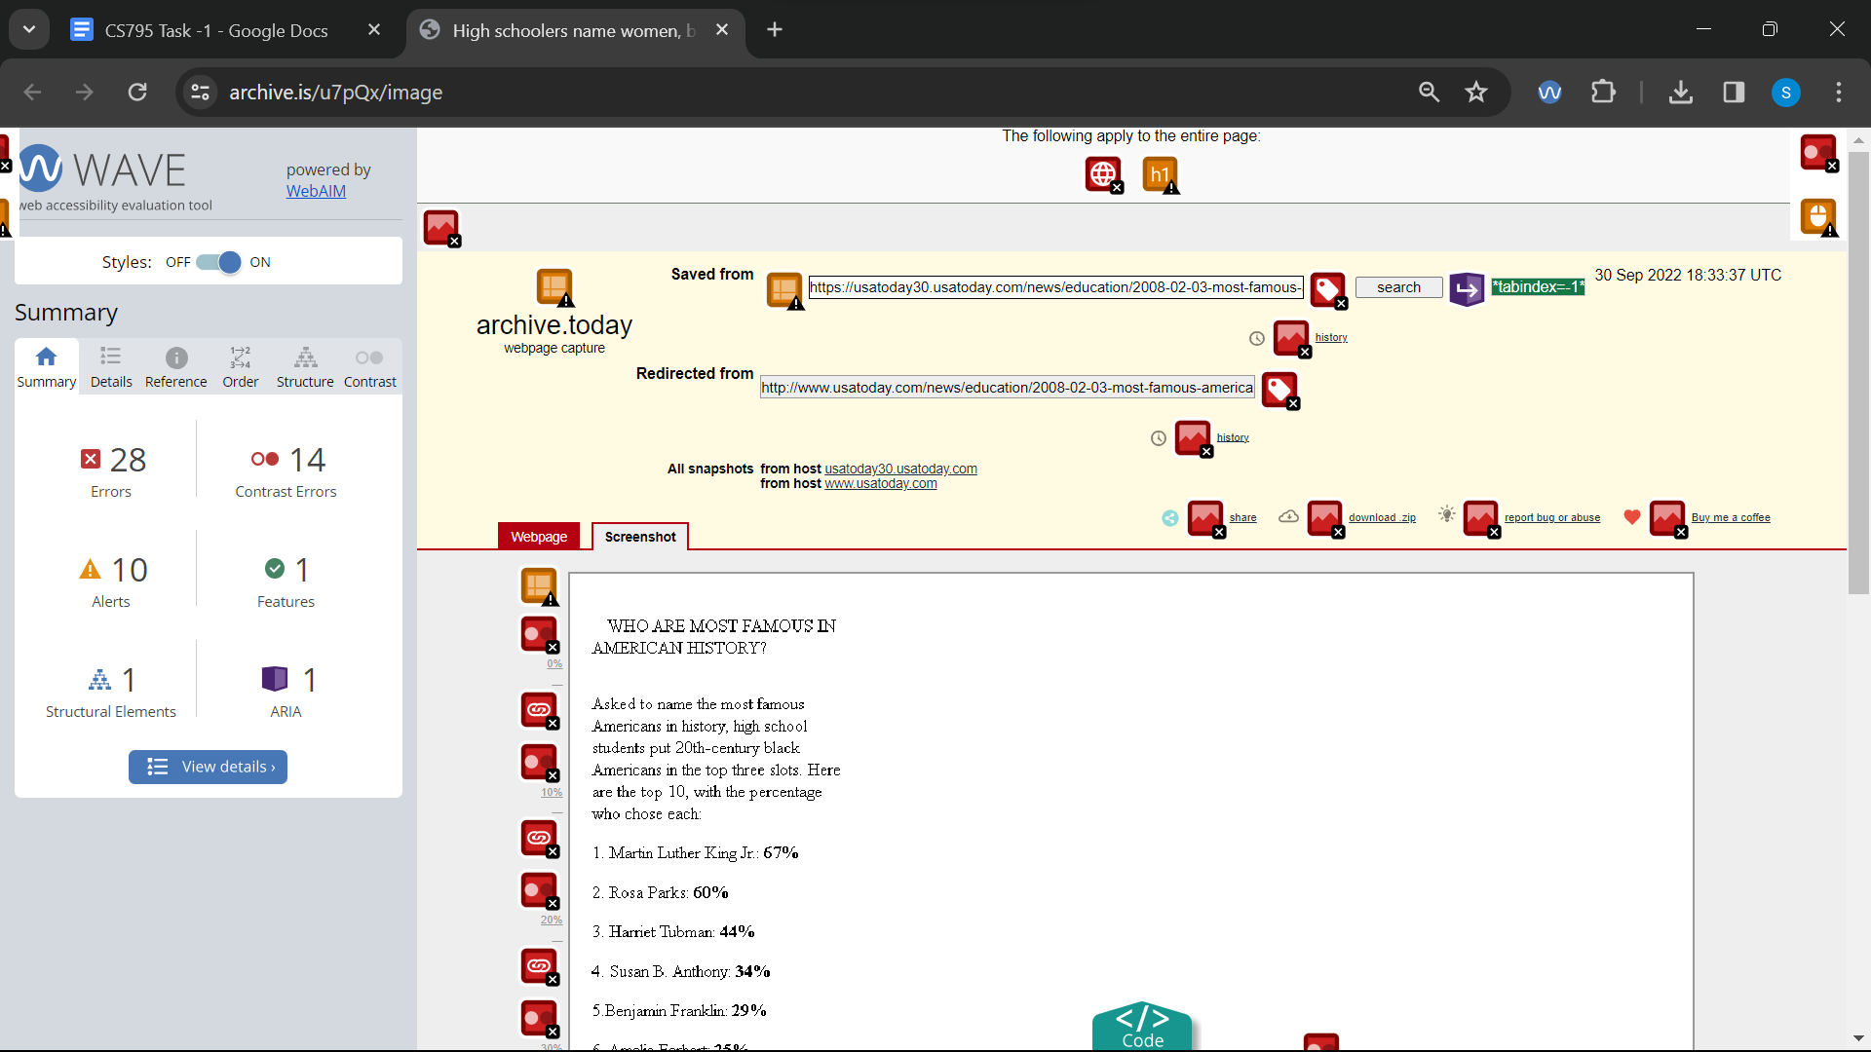

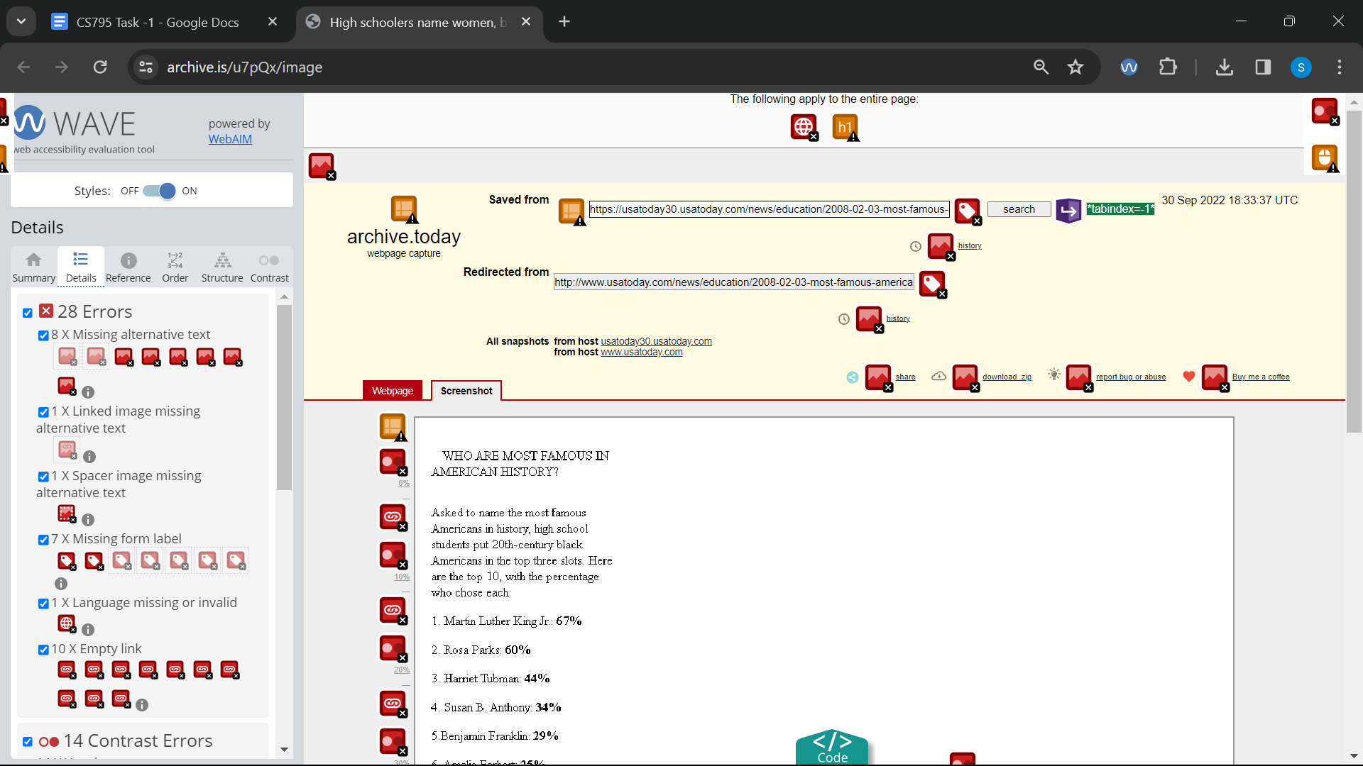

Link 25 : Wave : <https://archive.is/www.espn.com>

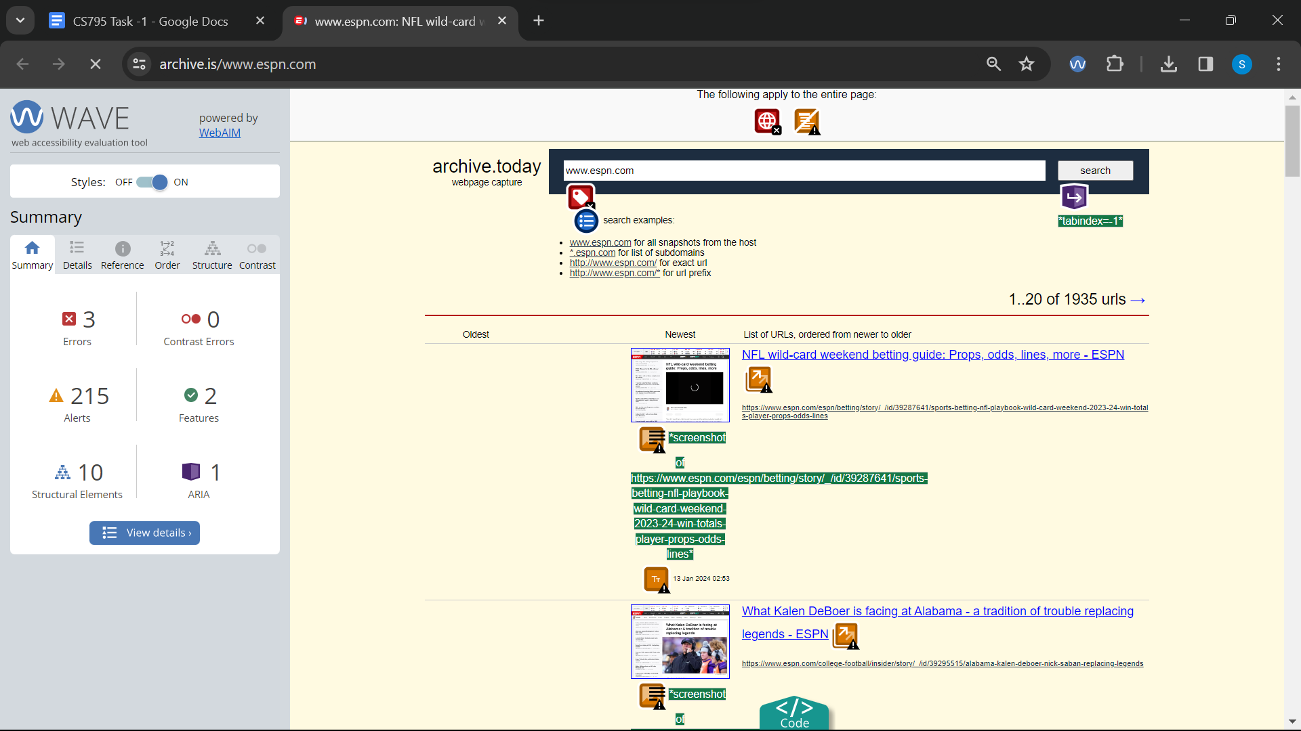

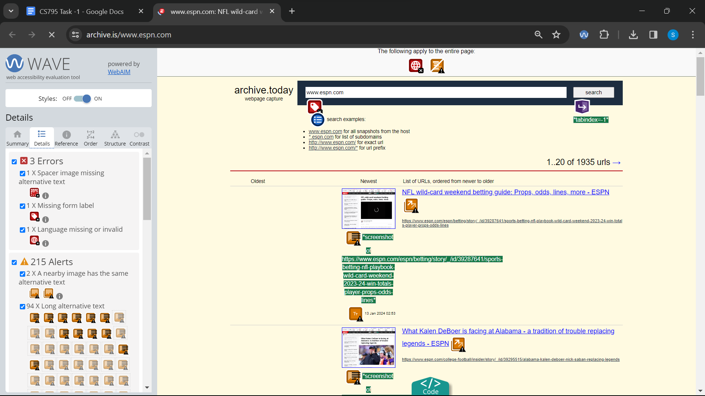

Link 26 : Wave: <https://archive.is/www.samsung.com>

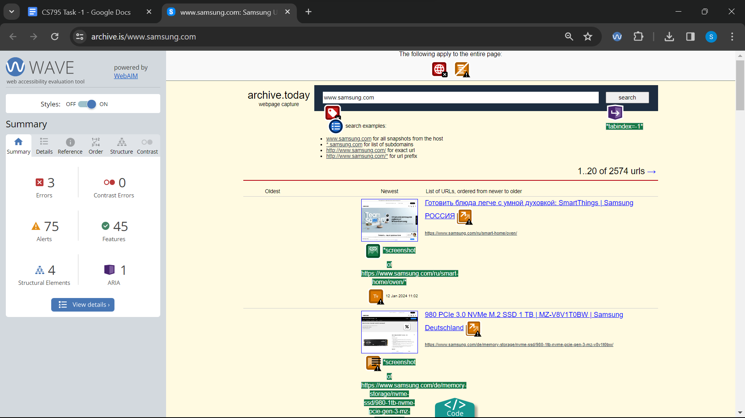

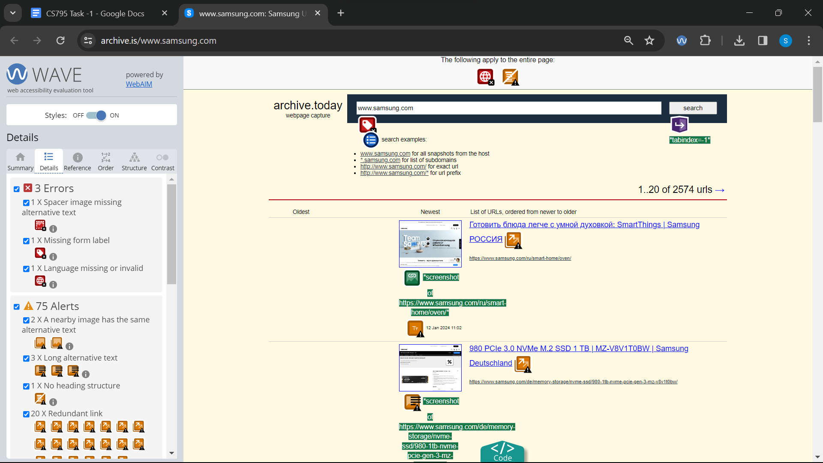

Link 27 : Wave: <https://archive.is/VwcBe>

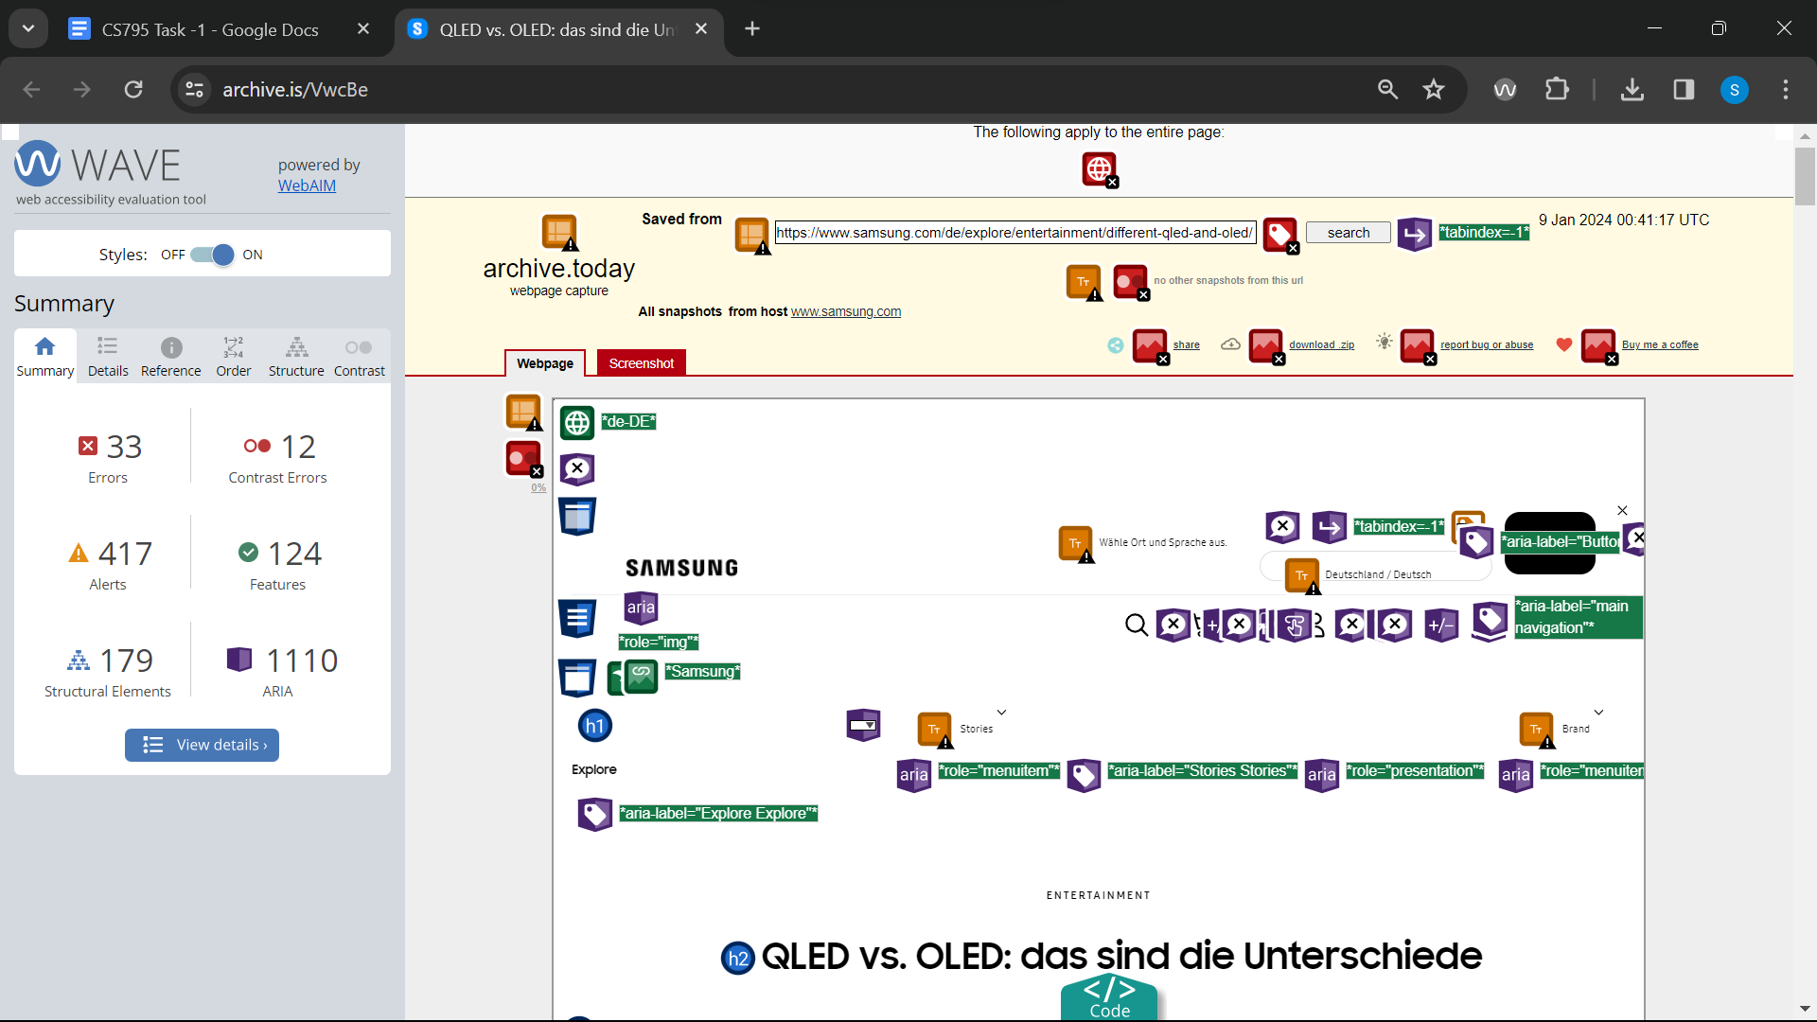

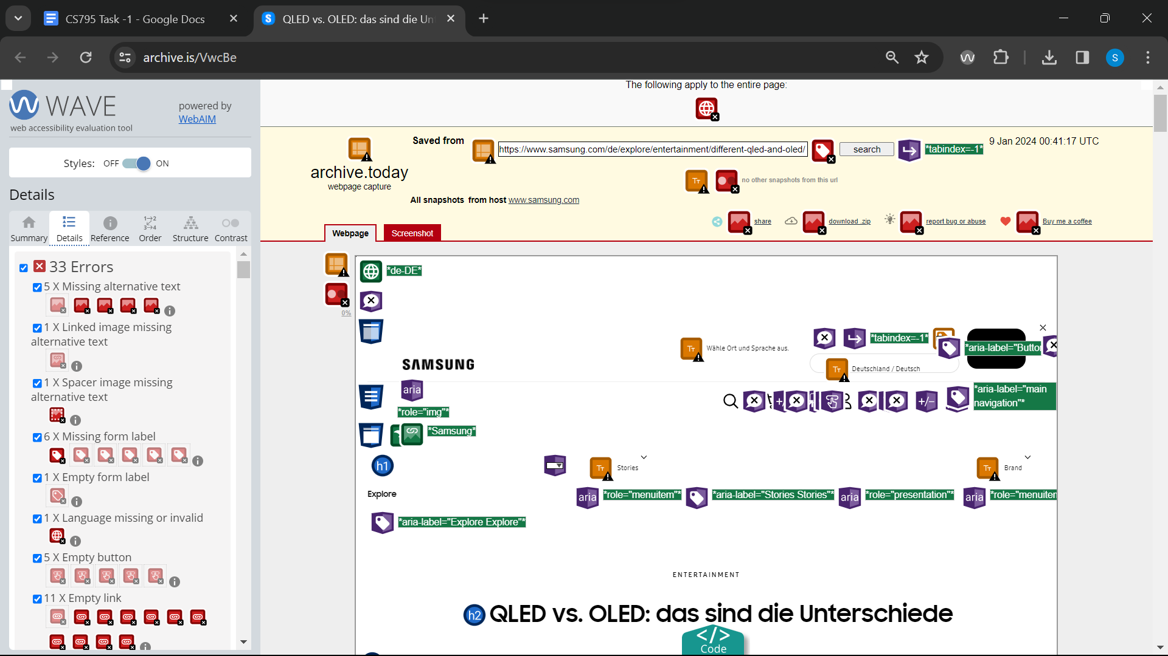

Link 28 : Wave: <https://archive.is/www.mcdonalds.com>

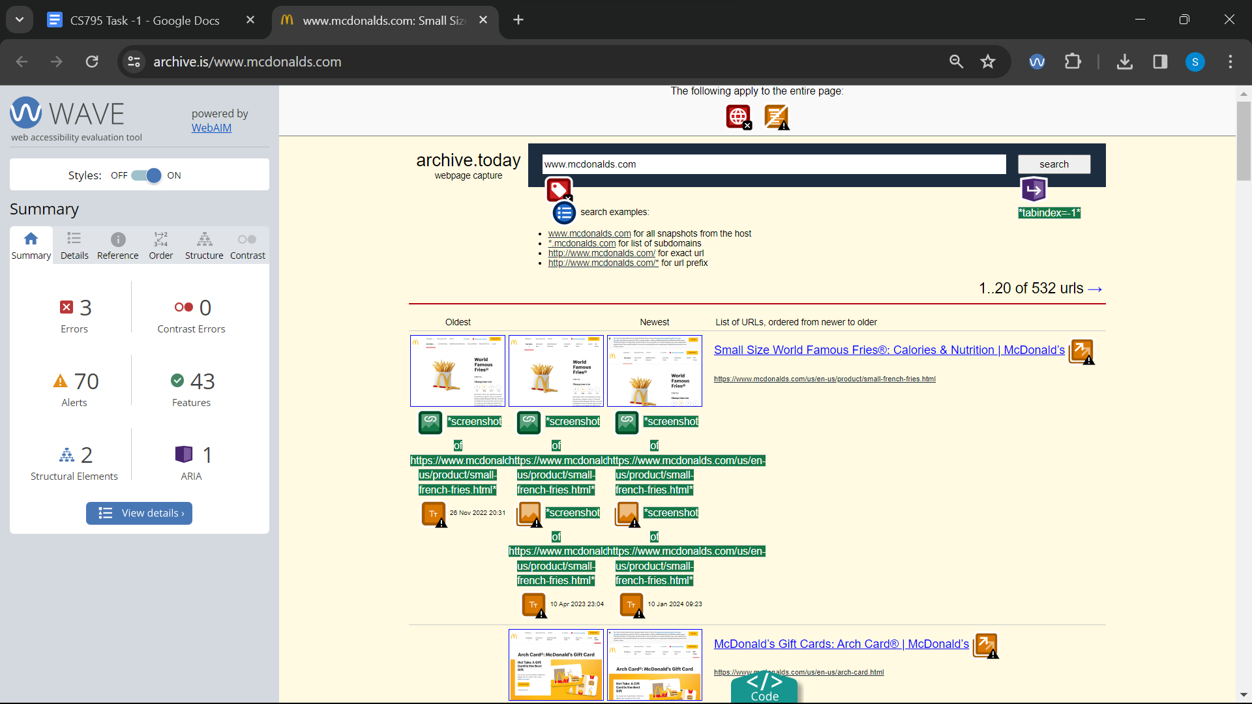

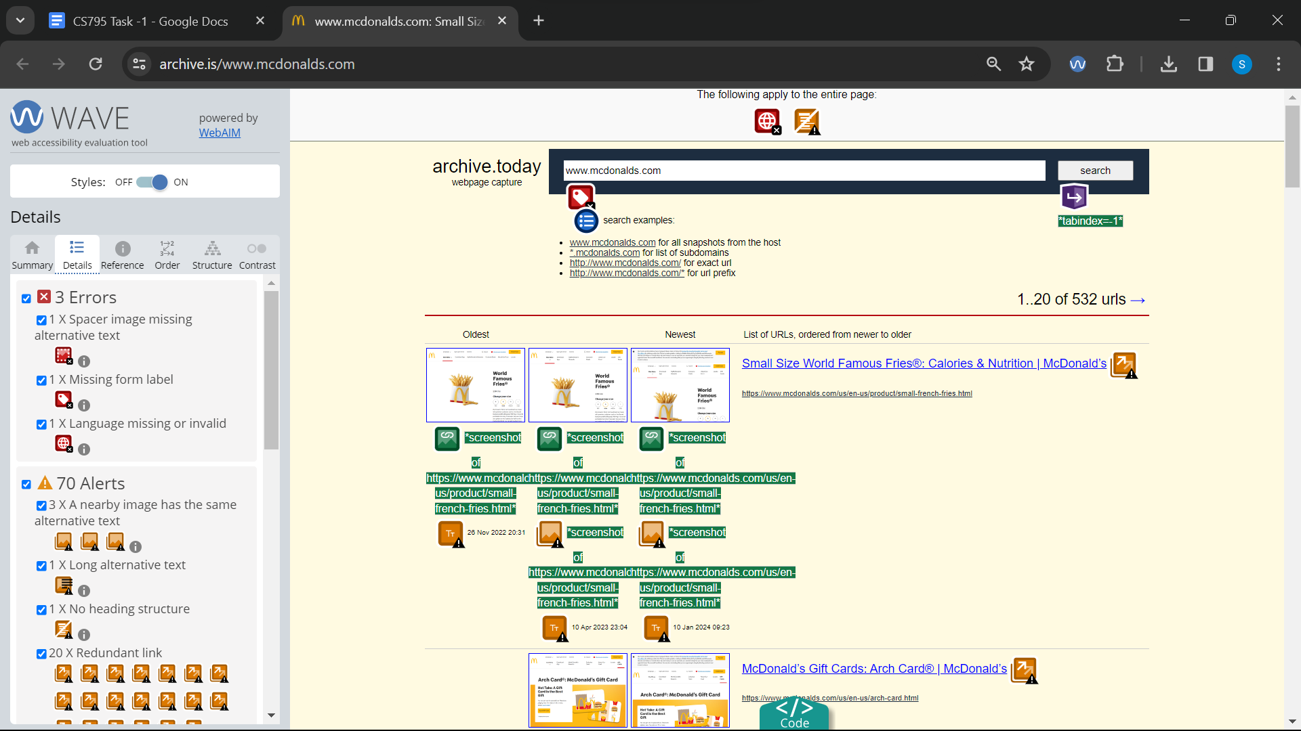

Link 29 : Wave: <https://archive.is/0mbgL>

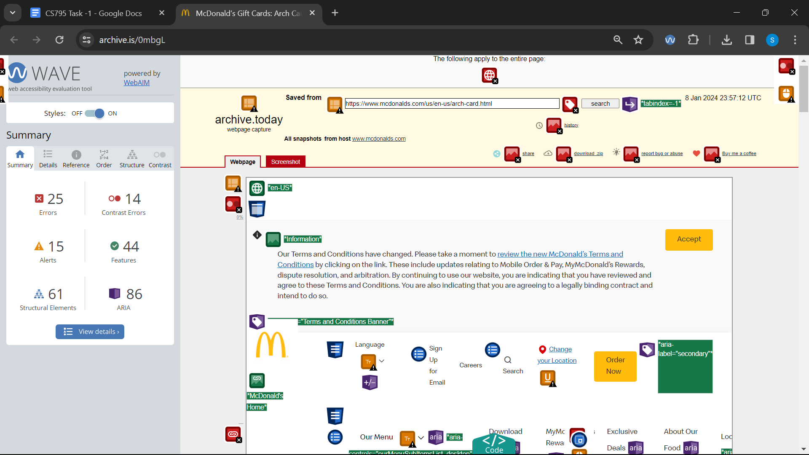

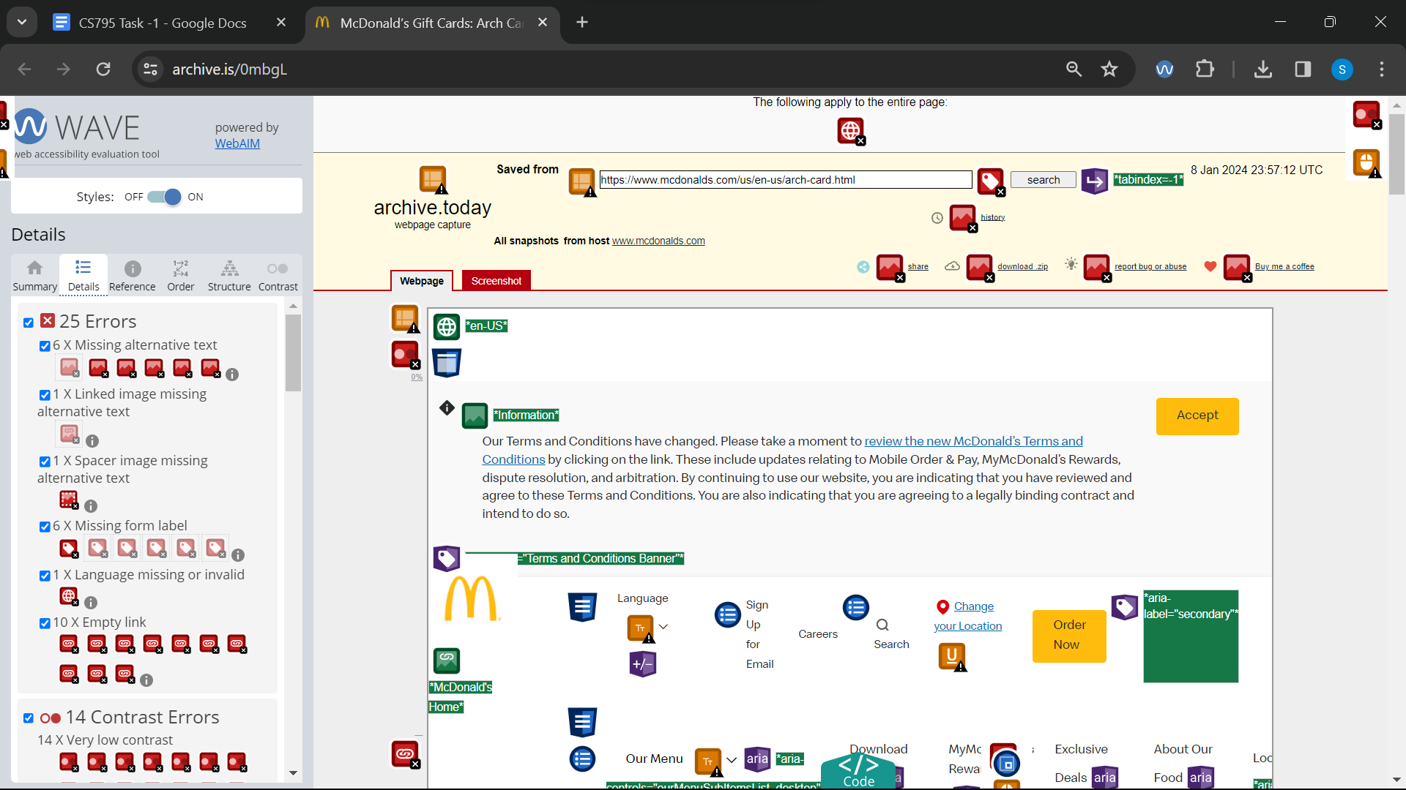

Link 30 : Wave: <https://archive.is/www.bmw.com>

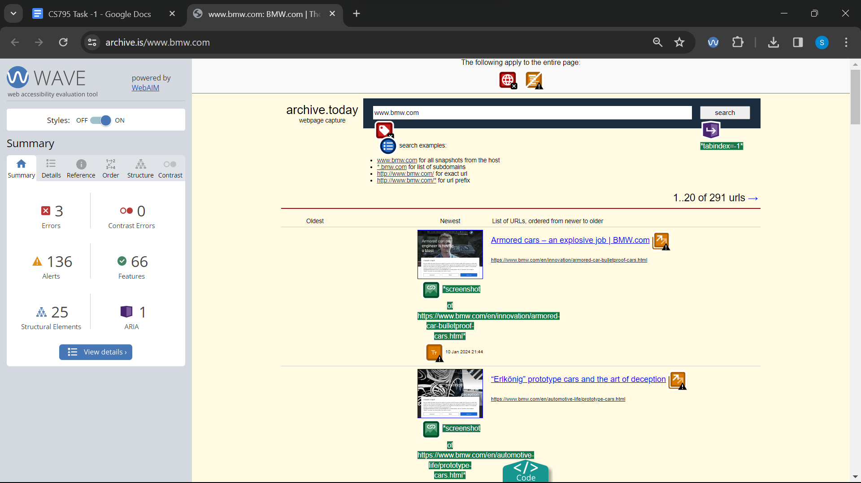

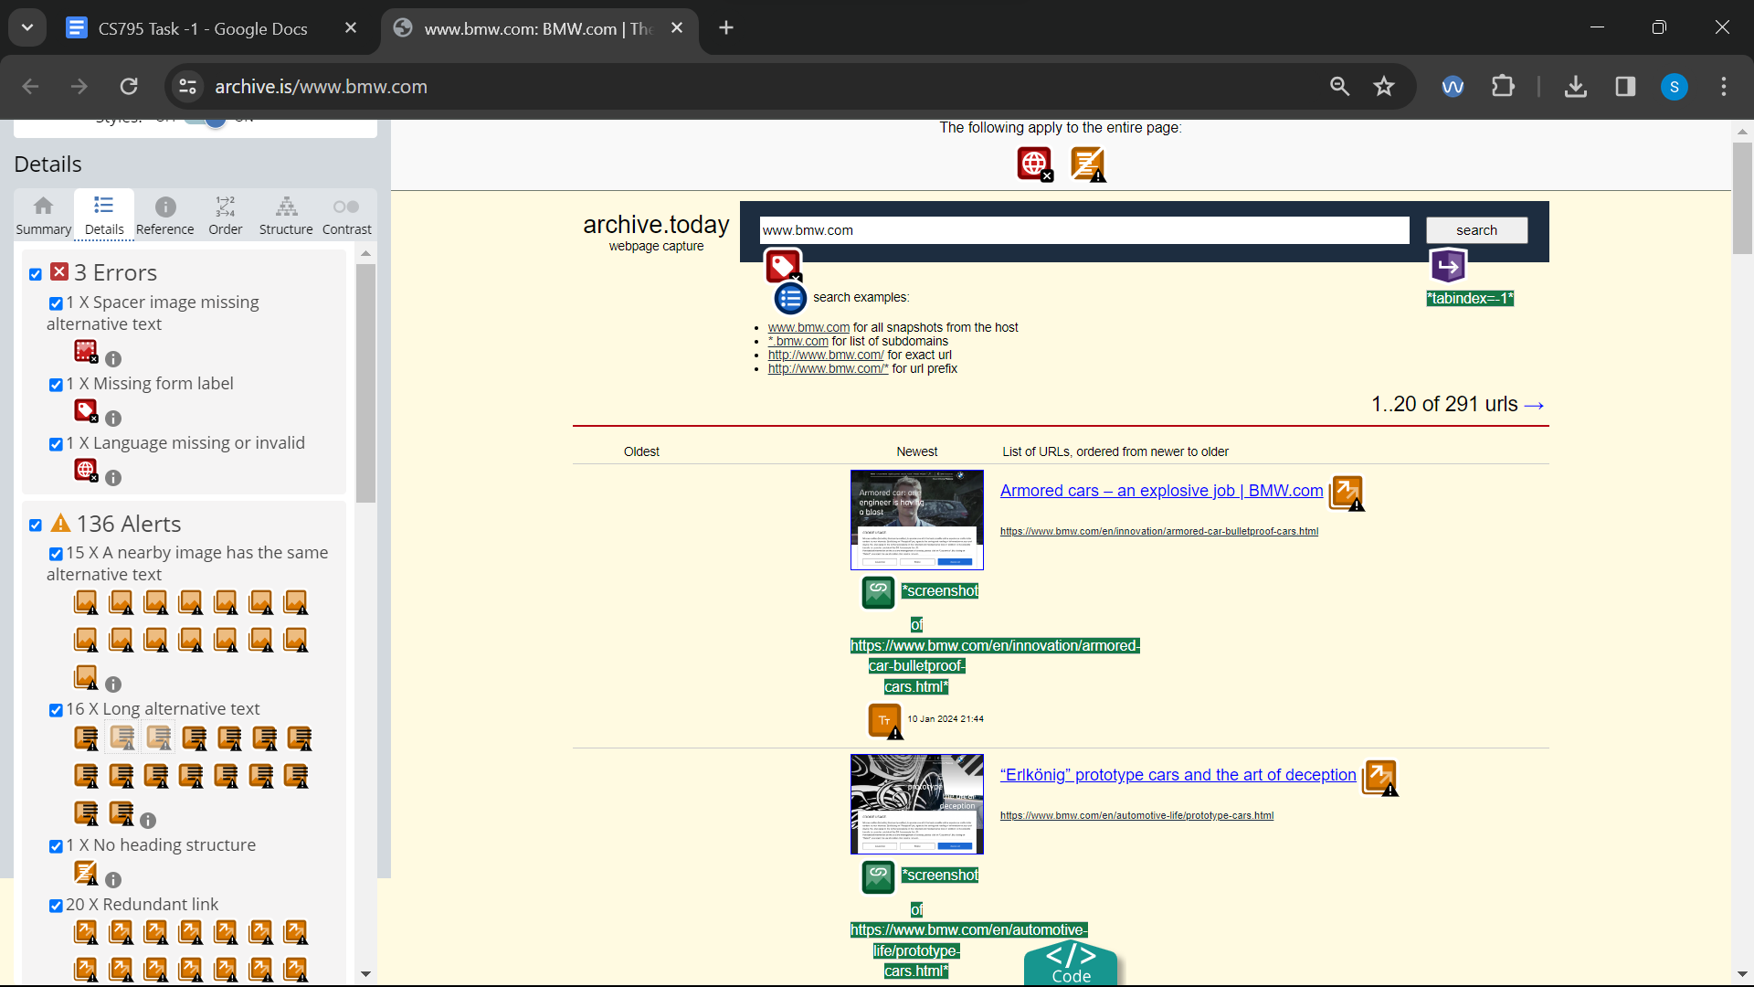

Link 31 : Wave: <https://archive.is/8uBtH>

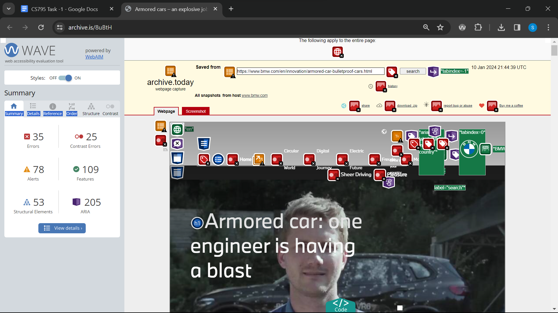

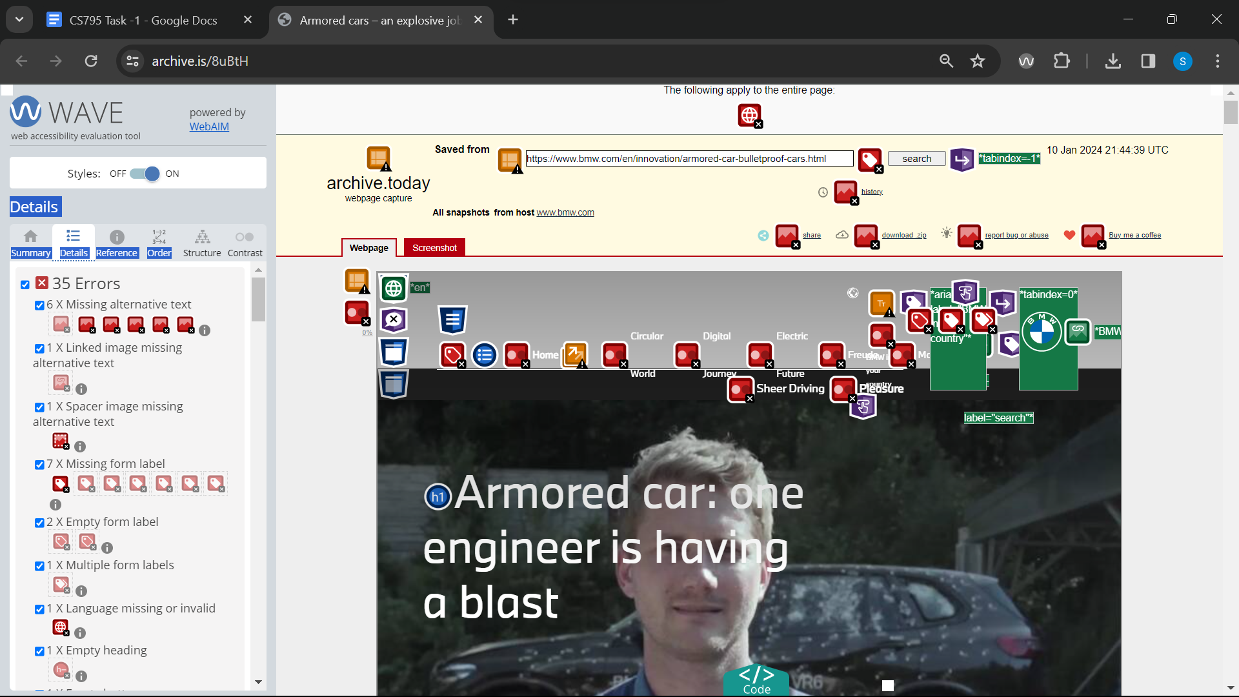

Link 32 : Wave: <https://archive.is/www.cartoonnetwork.com>

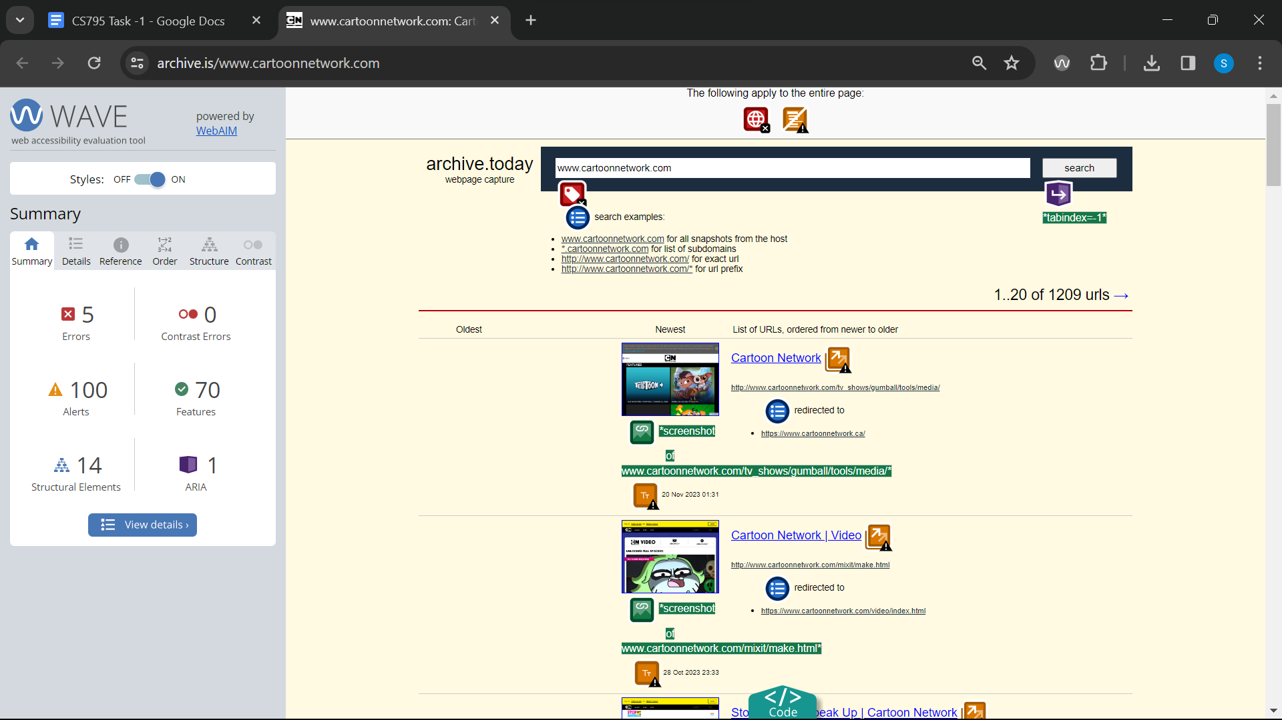

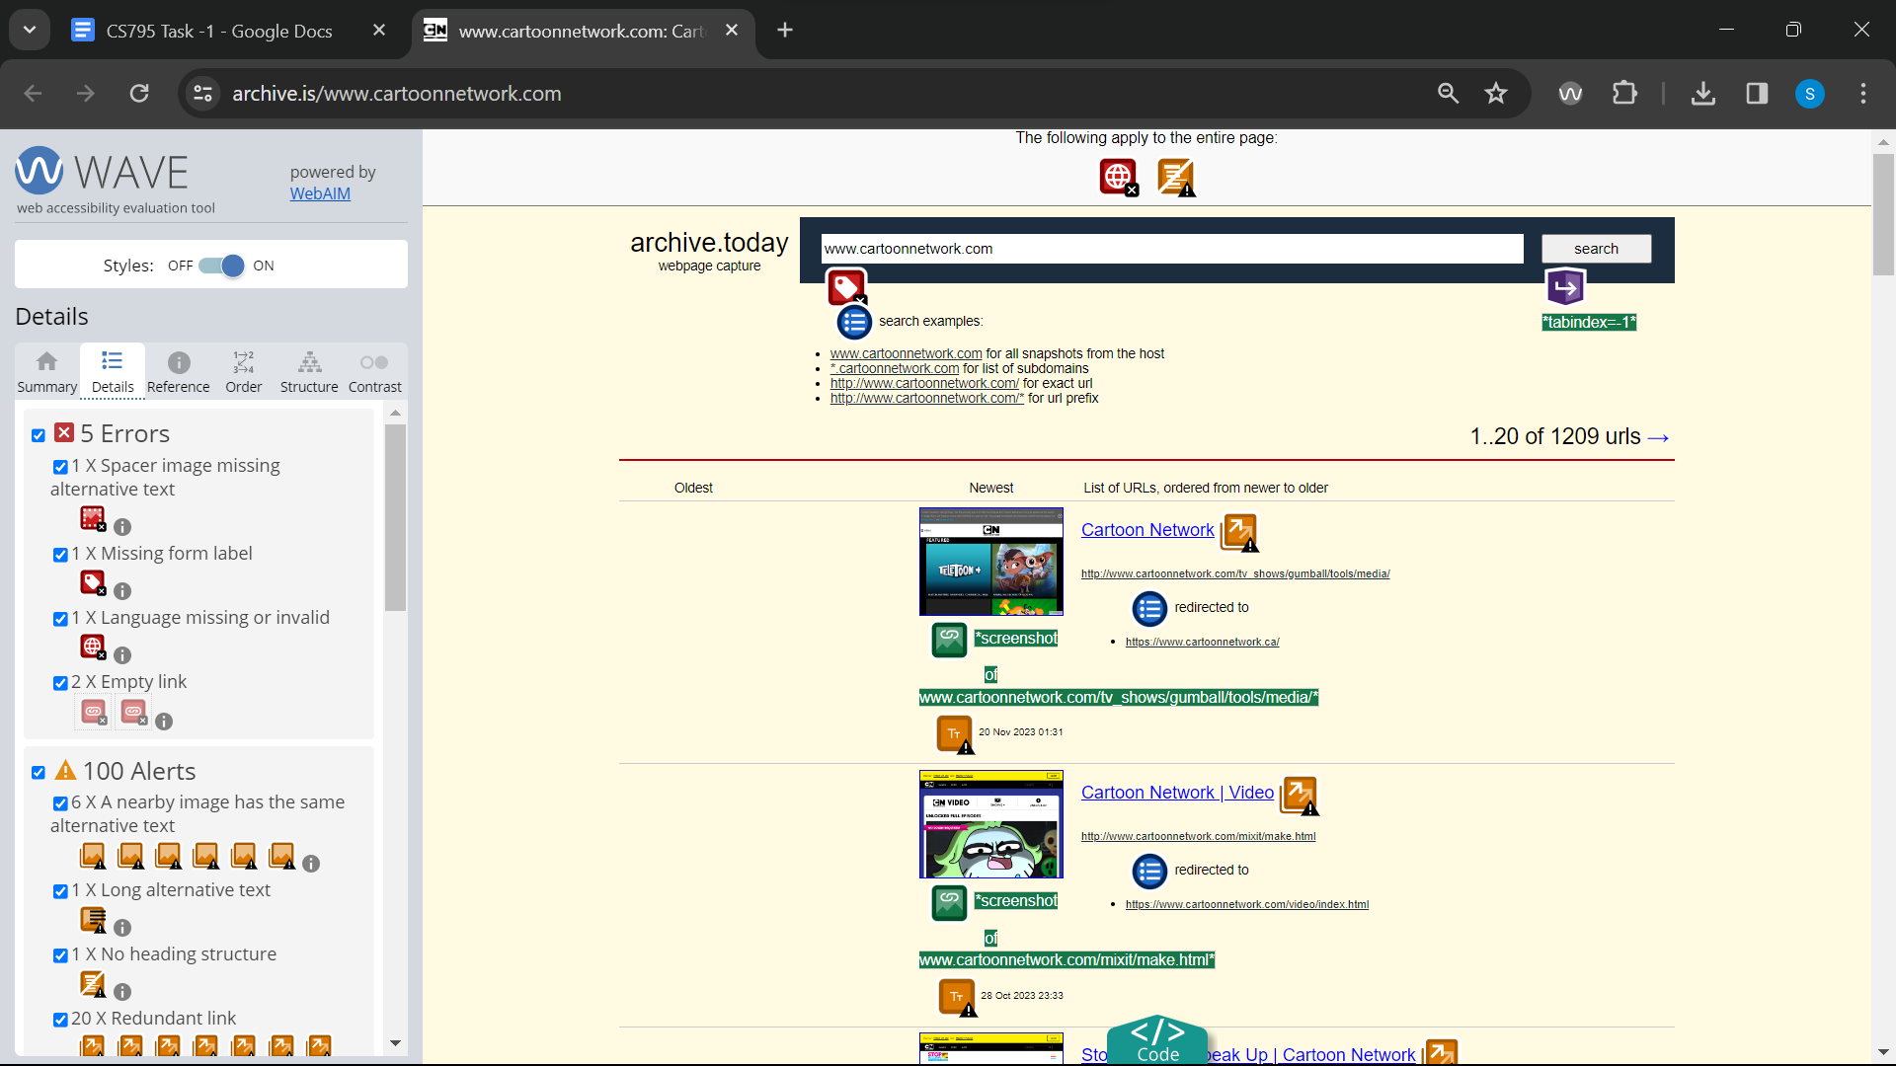

Link 33 : Wave: <https://archive.is/jZUqI>

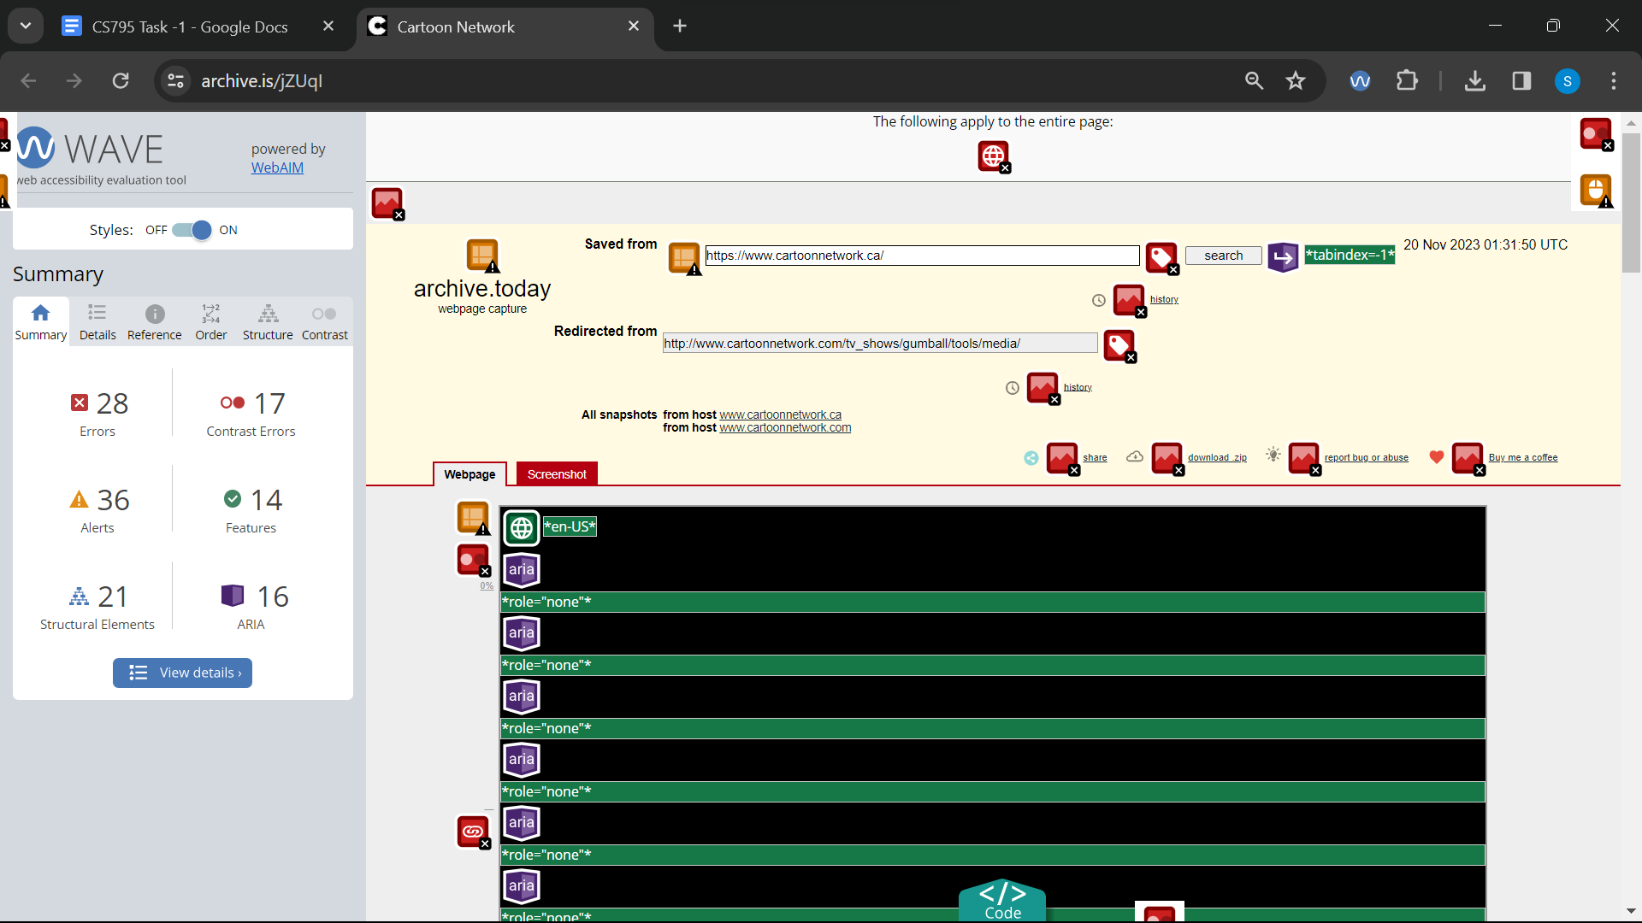

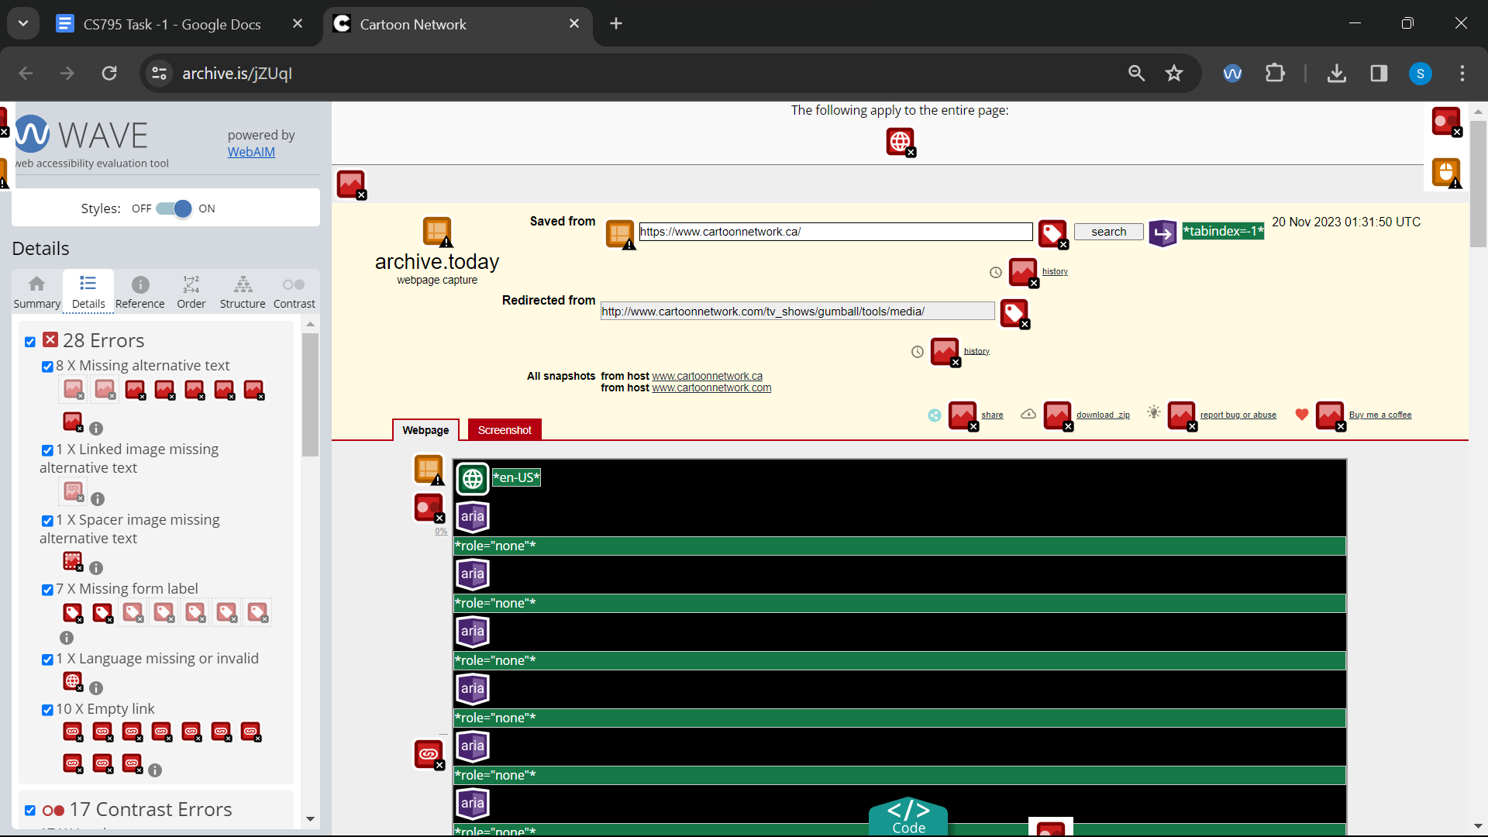

Link 34 : Wave: <https://archive.is/www.audi.com>

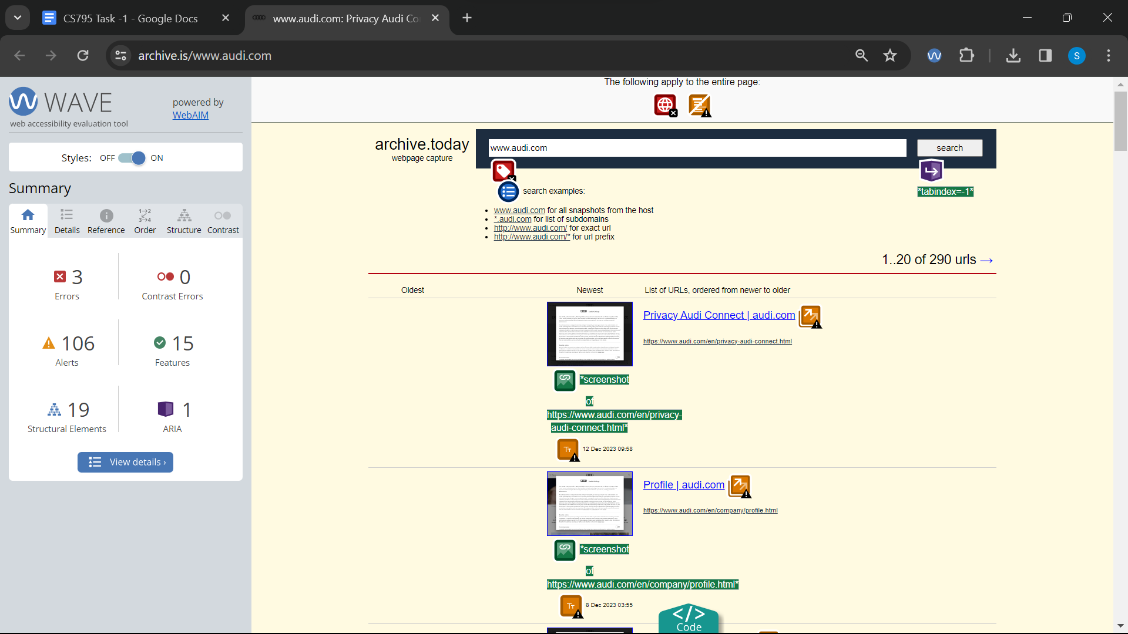

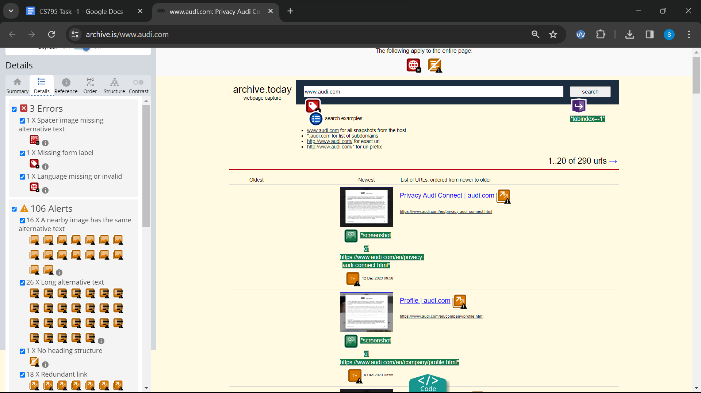

Link 35 : Wave: <https://archive.is/Pj6gm>

